**SURANA COLLEGE**

DEPARTMENT OF COMPUTER SCIENCE

#16, SOUTH END ROAD BANGALORE



A PROJECT REPORT ON

E-NOTES POINT

WHICH IS A BONAFIDE WORK OF

KAUSHIK B [18KXSB7040]

MANOJ S [18KXSB7049]

Students of Bachelor of Computer Science submitted in partial fulfilment of the requirement of the award of

DEGREE IN B.C.A prescribed by BANGALORE UNIVERSITY 2020-2021

Mrs. VIDYA A Dr. A SRINIVAS

(PROJECT GUIDE) HOD (COMPUTER SCIENCE)

EXAMINER ____________ EXAMINER _____________

**SURANA COLLEGE**

DEPARTMENT OF COMPUTER SCIENCE

#16, SOUTH END ROAD BANGALORE



A PROJECT REPORT ON

E-NOTES POINT

WHICH IS A BONAFIDE WORK OF

KAUSHIK B [18KXSB7040]

MANOJ S [18KXSB7049]

Students of Bachelor of Computer Science submitted in partial fulfilment of the requirement of the completion of

DEGREE IN

BACHELOR OF COMPUTER APPLICATIONS

Under the Guidance of

Mrs. VIDYA. A

(Asst.Prof)

DEPARTMENT OF COMPUTER SCIENCE

INDEX

|  |  |  |
| --- | --- | --- |
| SL.NO | CONTENT | PG.NO |
| 1. | Acknowledgement | 4 |
| 2. | Project synopsis | 5 |
| 3. | Project modules | 6 |
| 4. | SRS document | 7 |
| 5. | Data dictionary | 10 |
| 6. | Data flow diagram | 12 |
| 7. | ER diagram | 15 |
| 8. | Screenshots | 17 |
| 9. | Source code | 26 |
| 10. | Test case | 57 |
| 11. | Conclusion | 58 |
| 12. | Bibliography | 59 |

ACKNOWLEDGEMENT

The development of the project has been quite challenging and is it has been sincere effort to bring this project to its completion. The successful completion of this project wouldn’t have been possible without the continuous support and encouragement of many. We make use of this opportunity to thank all those who helped us in bringing out this project. We would like to express our gratitude to Dr. Srinivas.A for granting us permission to carry out this project work at college. We sincerely thank our guide Mrs. Vidya.A and all teachers for their constant help for our project during the course of this pandemic. Our project wouldn’t have made it this far if not for the online courses and tutorials from which we have learnt so much. We also thank all our friends for their valuable suggestions and encouragement.

Kaushik. B

Manoj. S

Project Synopsis

1. Problem Statement

Managing sharing of study notes may seem tricky, but this is part of user service system application support direct contact with user.

1. Objective

The objective of this project entitled “Study Notes Sharing Site” is to provide a user friendly and easily understandable GUI to users to easily upload subject notes. User can also update the notes details and delete the notes uploaded by him. This project also helps in administrative work such as management of notes and users. Admin can also monitor notes uploaded by user and able to accept or reject notes file.

1. Existing System

Only registered users can access the system. The user cannot view or add any information in the system when the server is down. The students can view only the data which are uploaded by then and the administrator.

1. Proposed system

The server allows the faculty to upload data and the students can opt to download the required documents through the site. The admin can control the notes that is uploaded by the student or the administrator.

The proposed system is worked on the server and all the files and documents are uploaded in the server. The students just need to register themselves and can surf all every detail related to the document very easily. Proposed system saves a lot of time to both students and administrator.

Feasibility Report

1. Technical Feasibility Study

The system is technically feasible because here we are using Python, Django and SQLite3 for database, which is free for commercial purposes. This system is also feasible for the users as it can satisfy user requirements and maintain their records in an organized way.

1. Operational Feasibility Study

The system is operationally feasible as it covers most functions on notes sharing and is dependable, as it is easy to use.

1. Economic Feasibility Study

The system is economically feasible as Python, Django and SQLite3 is open source and free for all. For users it is feasible as it is free to use.

Modules

Admin modules

* Manage (View/Delete) Users
* Manage (View/Delete) Notes
* Accept or Reject Notes
* Change Password

Student modules

* Upload notes
* Search notes via stream, title and subject
* Download notes
* Delete and Update notes
* Change password

Software Requirements Specification

1. Purpose

This E-notes Point system project document completely describes what the system should do without describing how the software will do it. The basic goal of requirement phase is to produce the SRS, which describes the complete external behaviour of the system.

1. Scope

The project has a wide scope, as it is not intended to a particular organization. This project is going to develop generic software, which can be applied by any business’ organization. Moreover, it provides facility to its users. Also, the software is going to provide a huge amount of summary data.

1. Developer’s Responsibility

The developer is responsible for:

1. Developing the system.
2. Installing the software on the client’s hardware.
3. Conducting user training that E-notes point report might be needed for using the system.
4. Maintaining the system for a period of two years after installation.

Product Description

In this project “**E-notes Point Project**” student and administrator can upload/download notes. Through the notes sharing process, users can upload, download and also view the study notes uploaded by others. User can also edit the notes uploaded by him. In this project two major modules that have been provided are administrator module and user module.

Goals

* All users can upload and share study notes with other users.
* Users can select the stream (branch) at the time of upload.
* User can upload notes in the pdf, doc, ppt, zip, txt etc. file format.
* User can search notes via branch, subject and title.
* Administrator or management can manage the users and notes.
* Admin can accept or reject the notes uploaded request. Notes can be published only after accepted by admin.

1. General Requirements

During the Requirement Analysis Phase, the development team analyzes the requirements to be fulfilled by the E-notes Point website and identifies the probable approach for meeting these requirements. To identify the requirements, we decided to study the existing process of uploading and storing the details of opening account and notes uploading.

Finally, it was identified that the notes sharing project should:

* Enable new users to fill the signup form and should be able to login.
* Enable to update the profile later if needed.
* Can upload, view and download notes that has been uploaded by them as well as others.
* Admin can also upload, view, delete the notes. And can accept and reject the notes

uploaded by users and delete the user as well.

* Admin can change password if necessary.
* The webpage should be user friendly and well designed.
* It should be able to handle exceptions and run time errors.

Usage Scenario

The E-notes Point project provides usage scenario for the software. It has organized information collected during requirements elicitation into use-cases.

1. User Profiles

There will be two levels of users:

* Administrator level
* User level

1. Use Cases

* Administrator level

The admin can upload, view, delete the notes and accept or reject notes.

* User level

The user can upload, delete notes and can also view the notes uploaded by others.

Data objects and description:

During the requirement analysis phase, the development team examines the system. After examining al the process and feasibility, the following points were considered while designing the database:

* It should store the registered information of both users and administrator.
* It should store the uploaded notes and details of the file.

Functional Requirements

* Edit profile
* Upload notes
* View notes
* Change password
* Manage users
* Manage notes
* Download notes
* Administrator

Non-Functional Requirements

Usability

The user interface of the system will be user friendly so it will be easy for the user to use the system.

Reliability

The system would be easy to maintain and able to carry further extensions occurred.

Performance

The system should provide the services in considerable time interval.

Security

The information provided by the user should authenticated which protect the system from external attack and spamming.

Data Dictionary

User Register Table

|  |  |  |  |
| --- | --- | --- | --- |
| **COLUMN NAME** | **DATATYPE** | **PRIMARY KEY** | **NOT NULL** |
| User id | integer | Yes | Yes |
| Contact | Varchar(10) | No | No |
| Branch | Varchar(30) | No | Yes |
| Role | Varchar(15) | No | Yes |

Query

CREATE TABLE “user_signup” (“id” integer NOT NULL PRIMARY KEY AUTOINCREMENT, “contact” varchar(10) NULL, “branch” varchar(30) NOT NULL, “role” varchar(15) NOT NULL, “user_id” integer NOT NULL REFERENCES “auth_user” (“id”) DEFERRABLE INITIALLY DEFERRED)

Notes Table

|  |  |  |  |
| --- | --- | --- | --- |
| **COLUMN NAME** | **DATATYPE** | **PRIMARY KEY** | **NOT NULL** |
| User id | Integer | Yes | Yes |
| Uploadingdate | Varchar(30) | No | Yes |
| Branch | Varchar(30) | No | Yes |
| Subject | Varchar(30) | No | Yes |
| Notesfile | Varchar(100) | No | Yes |
| Filetype | Varchar(15) | No | Yes |
| Status | Varchar(15) | No | Yes |
| description | Varchar(200) | No | No |

Query

CREATE TABLE “notes_notes” (“id” integer NOT NULL PRIMARY KEY AUTOINCREMENT, “uploadingdate” varchar(30) NOT NULL, “branch” varchar(30) NOT NULL, “subject” varchar(30) NOT NULL, “notesfile” varchar(100) NULL, “filetype” varchar(30) NOT NULL, “status” varchar(15) NOT NULL, “user_id” integer NOT NULL REFERENCES “auth_user” (“id”) DEFERRABLE INITIALLY DEFERRED, “description” varchar(200) NULL)

Data Flow Diagram (DFD)

A data flow diagram (DFD) is a graphical representation of the “flow” of data through and information system. A data flow diagram can be used for visualization of data processing. It is a common practice for designer to draw context level DFD first which was the interaction between the system and outside entities. This context level DFD yes then exploded to show more details of the system being modeled.

A DFD represents flow of data through a system. Data flow diagrams are commonly used in urine problem analysis. It views a system as a function that transforms the input into desired output. A DFD shows moment of data through the different transformations or processes in the system.

Data flow diagrams can be used to provide the end user with a physical idea of where the data they input ultimately has an effect upon the structure of the whole system from order to dispatch to restock any system is developed can be determined through a data flow diagram. The appropriate register saved in database and maintained by appropriate authorities.

Data flow diagram notation

Function

database

input/output

flow

Level 0 DFD

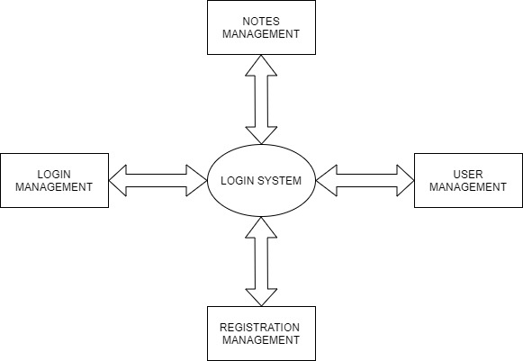

LEVEL 1 DFD

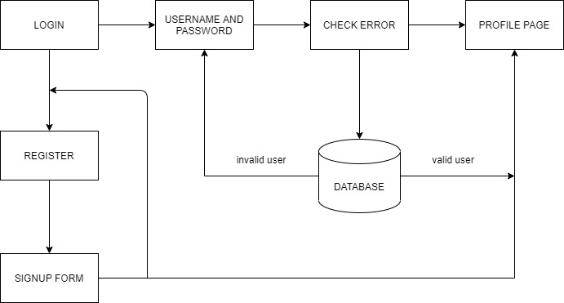

LEVEL 2 DFD

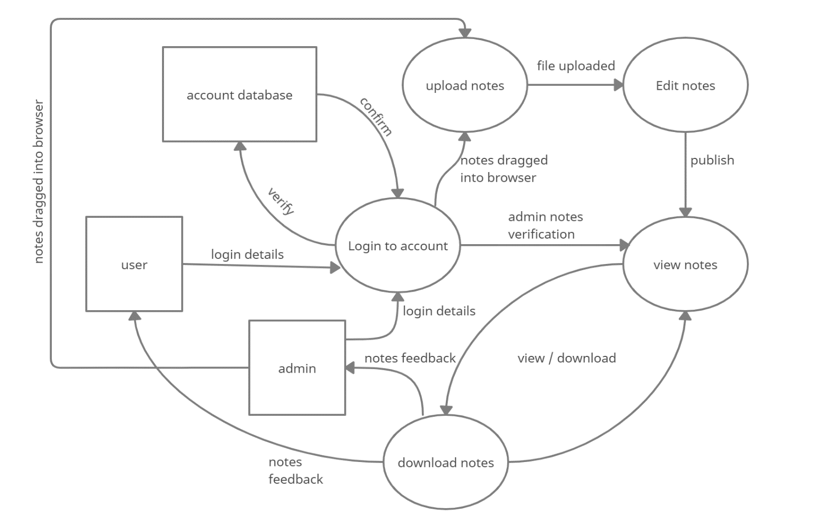

Entity relationship diagram (ER-diagram)

Entity relationship diagram is a specialized graphic that illustrates the interrelationship between entities in a database. ER diagrams often use symbols to represent 3 different types of information. Boxes are commonly used to represent entities. Diamonds are normally used to represent relationships and ovals are used to represent attributes.

An entity relationship model in software engineering is an abstract and conceptual representation of data. Entity relationship modelling is a relation schema database modelling method, used to produce a type of conceptual schema or semantic data model of a system, often a relational database, and its requirements in a top-down fashion.

Symbols used in this E-R diagram:

Entity: Entity is a “thing” in the real world with an independent existence. An entity may be an object with a physical existence such as person, car or employee. Entity symbol is as follows

Attribute: Attribute is a particular property that describes the entity. Attribute symbol is

Relationship: Relationship will be several implicit relationships among various entity types whenever an attribute of one entity refers to another entity type some relationship exits. Relationship symbol is

ER diagram:

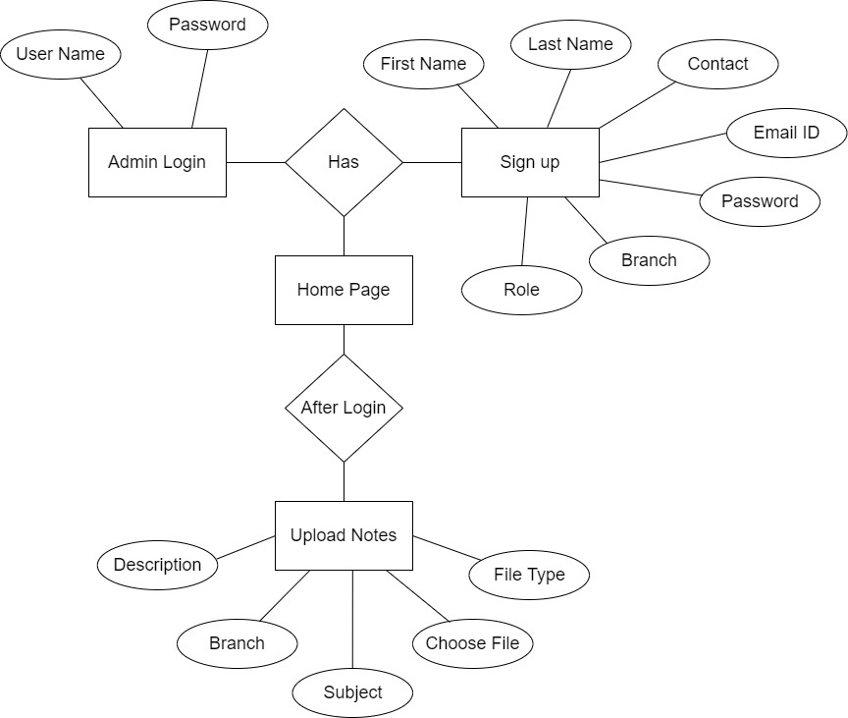

Screenshots

Home Page

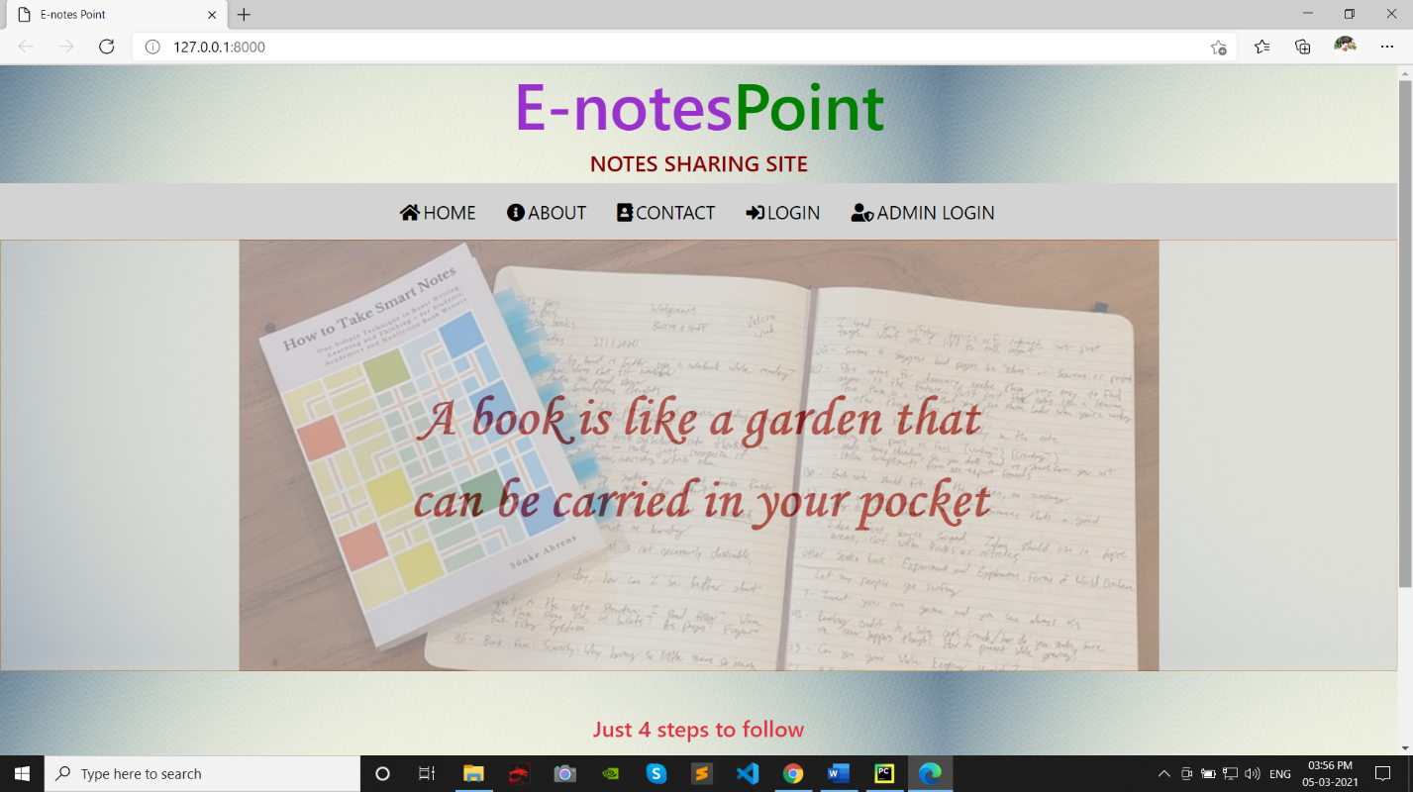

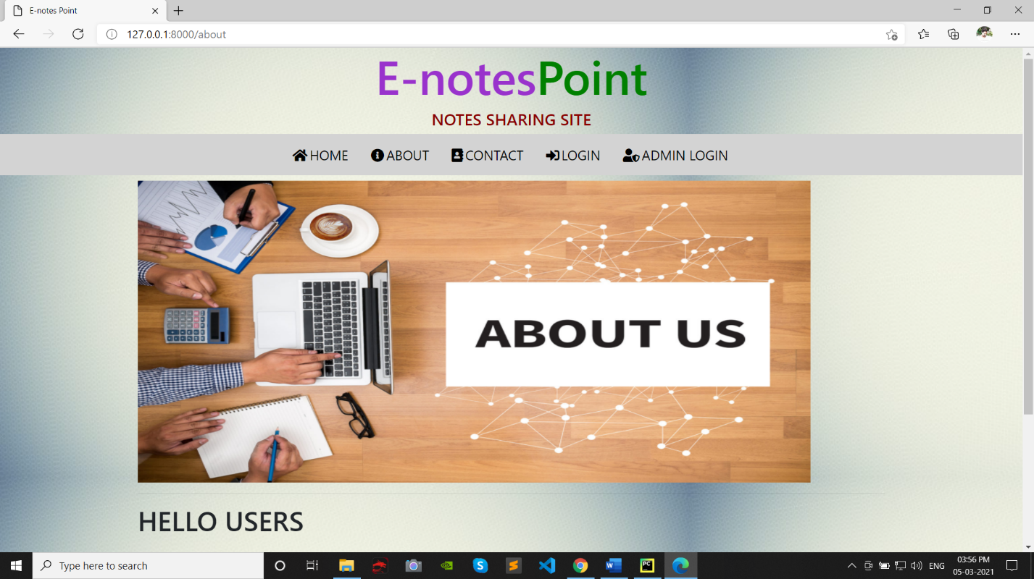

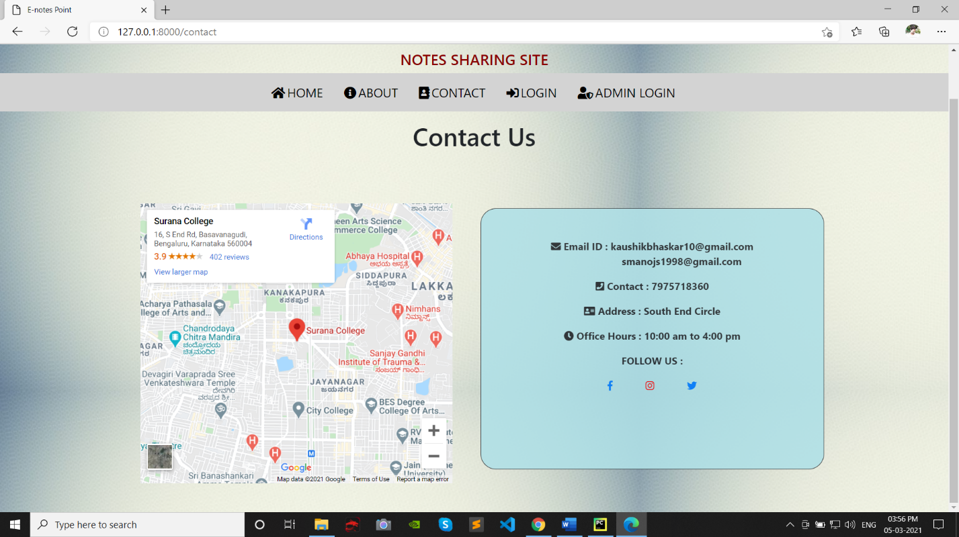

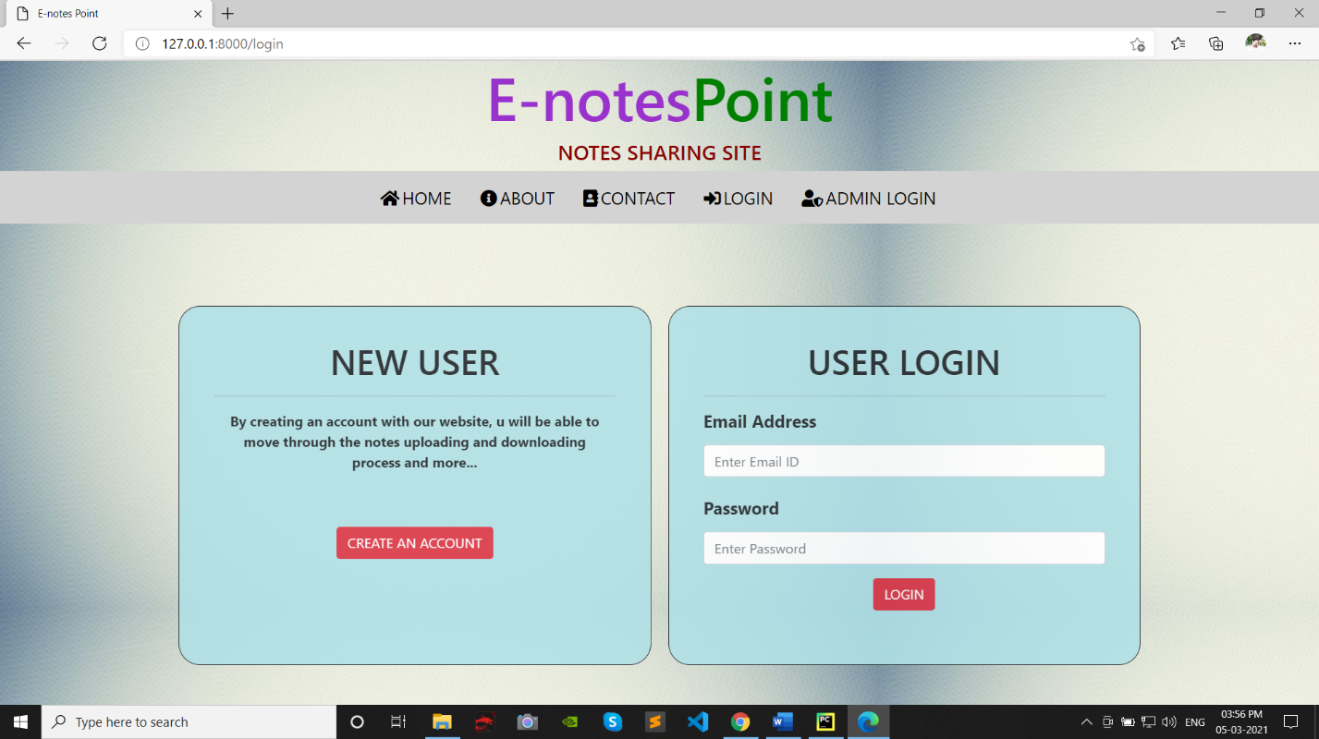

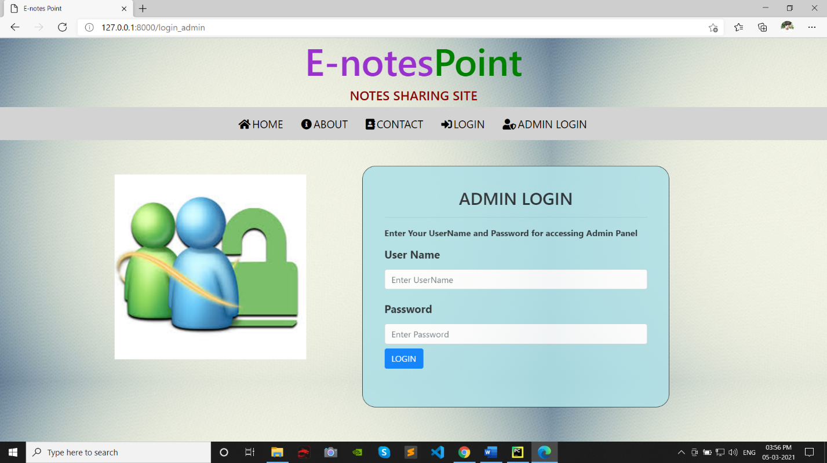

Sign up page

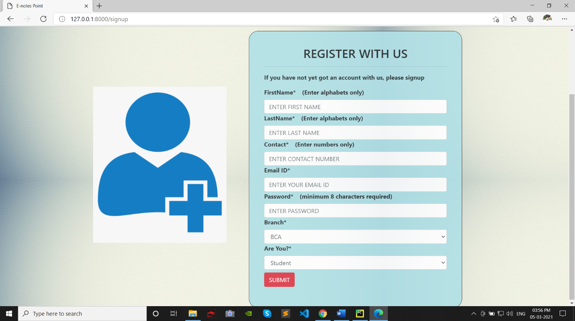

Login page

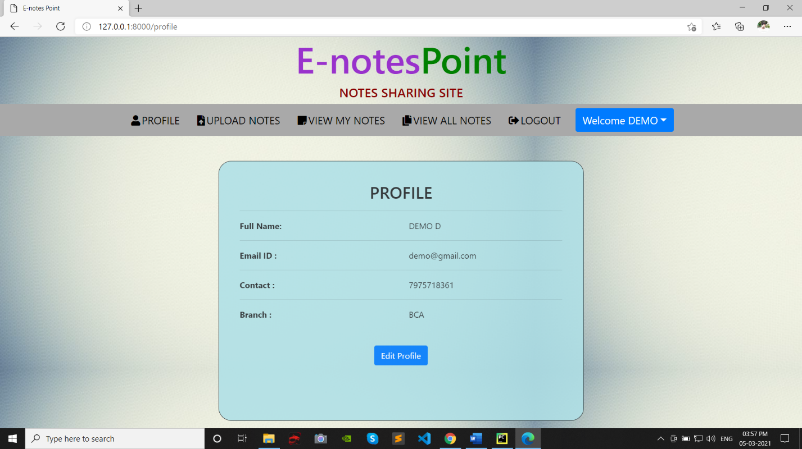

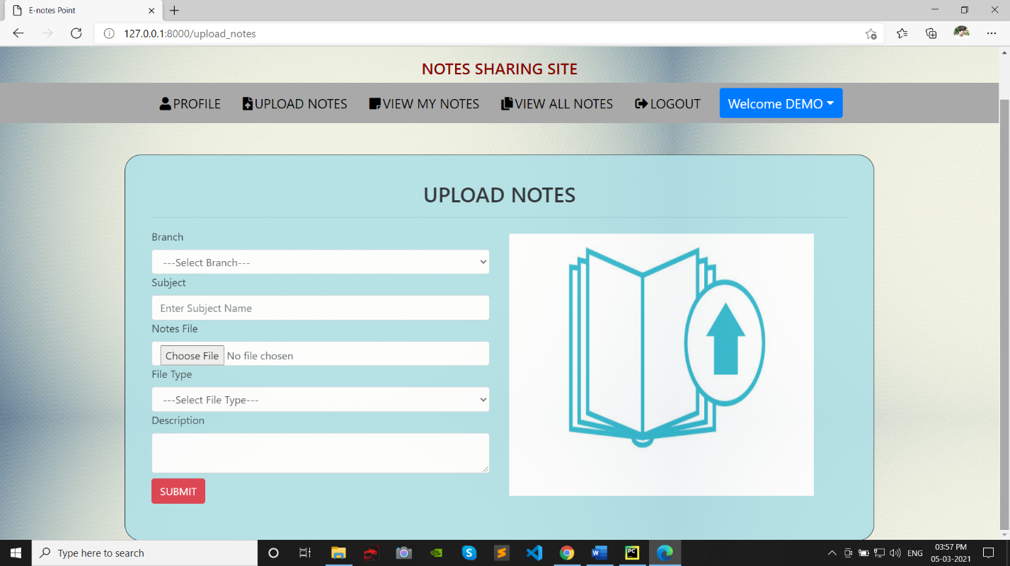

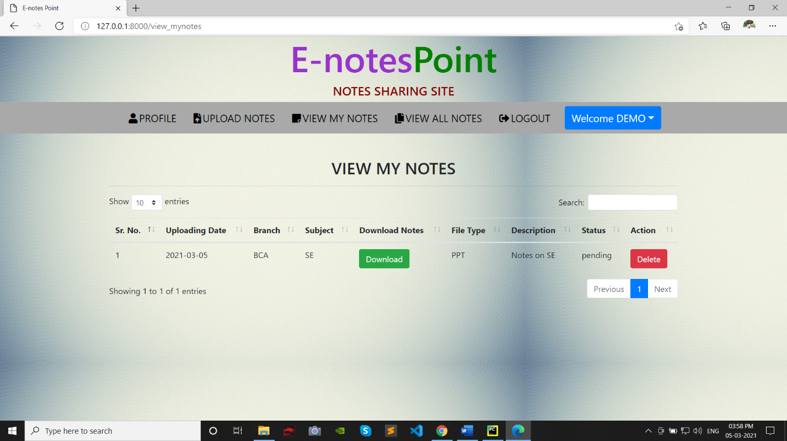

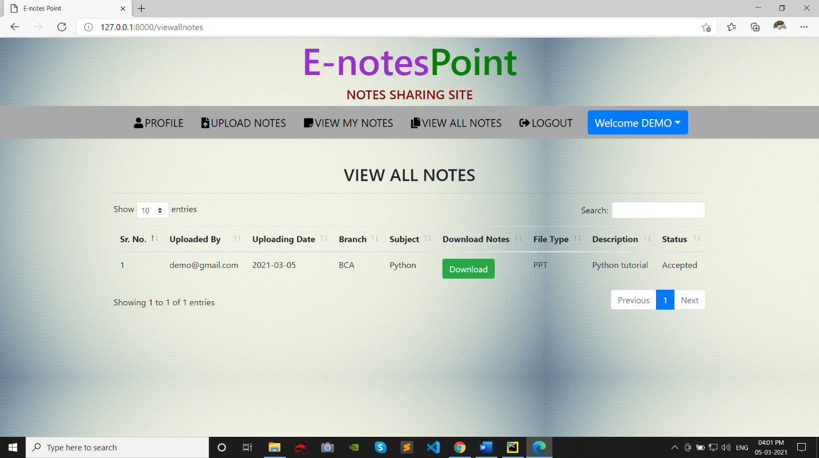

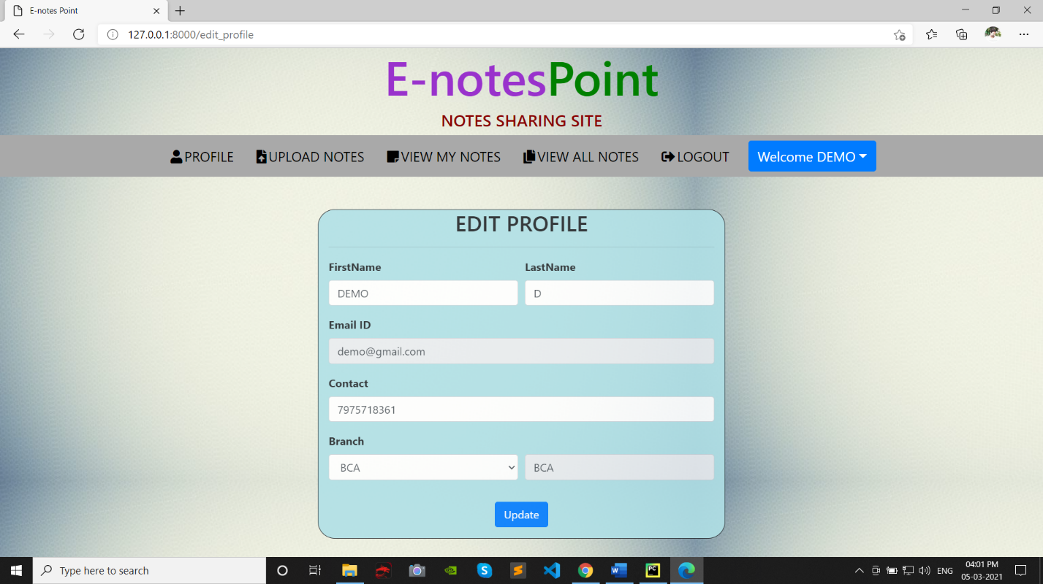

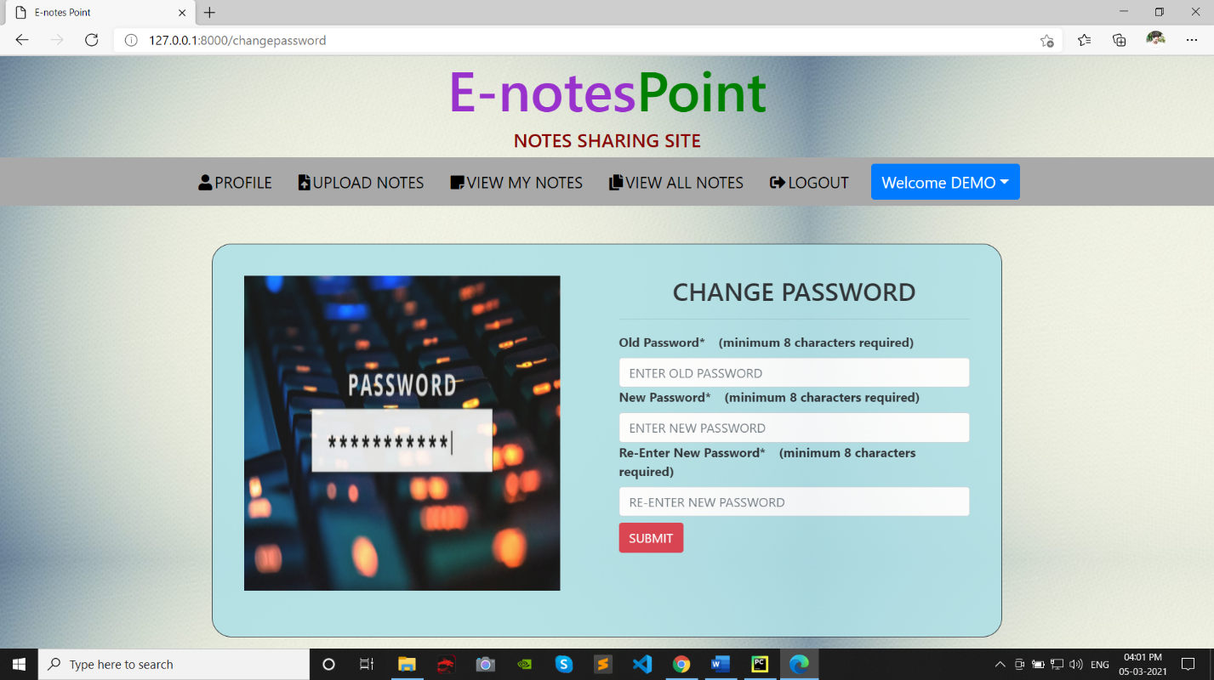

Admin page

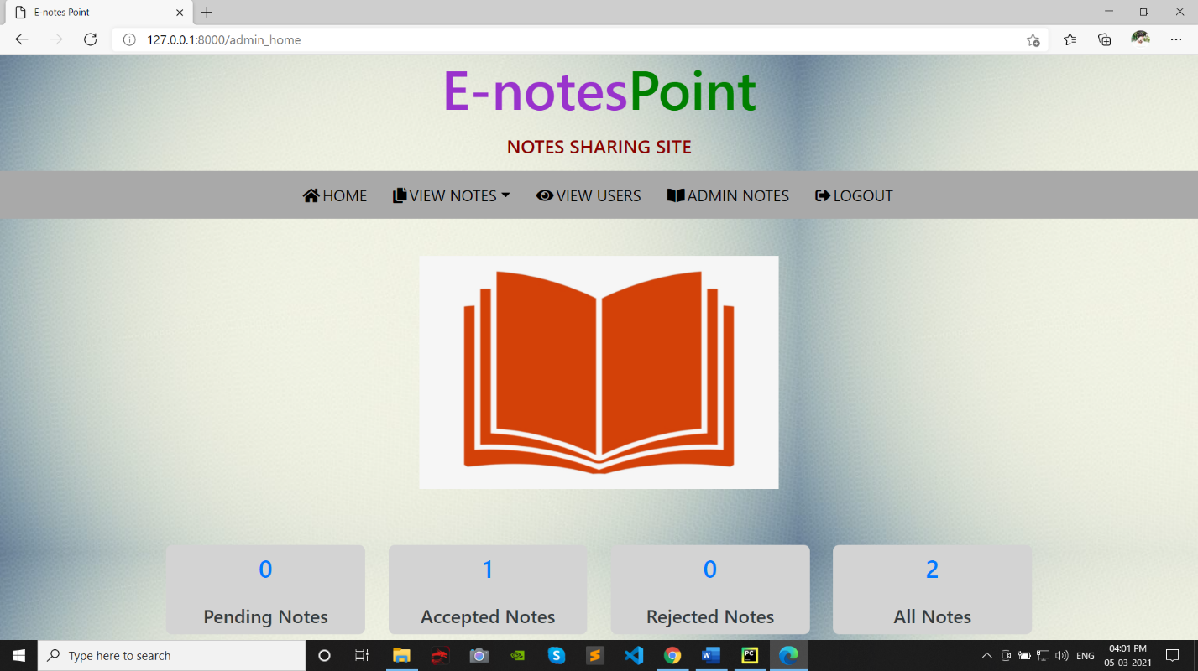

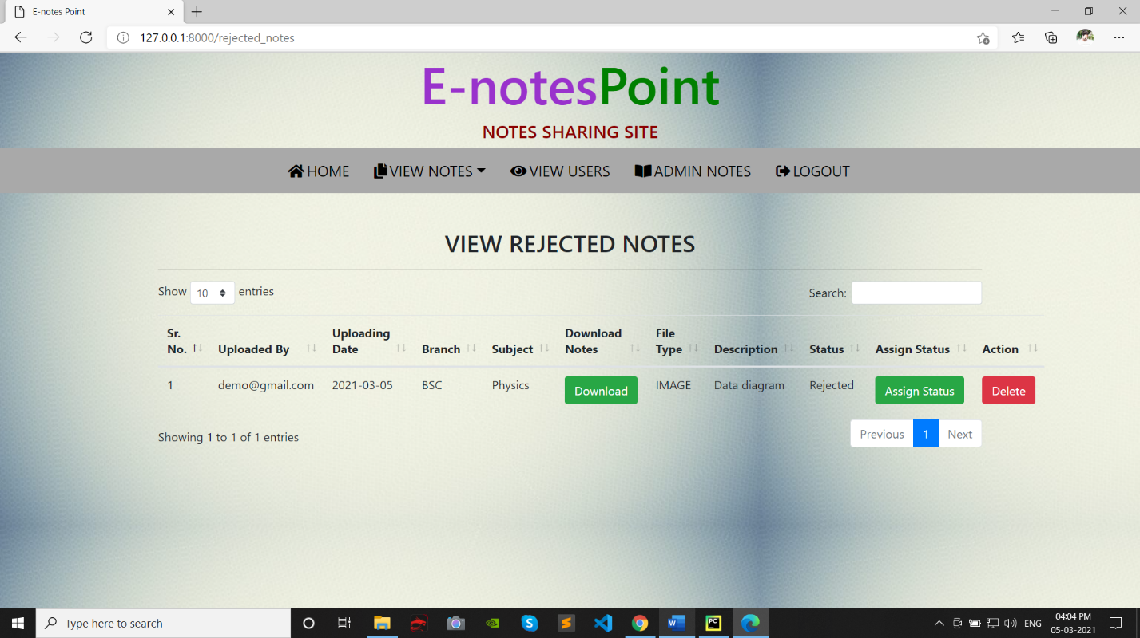

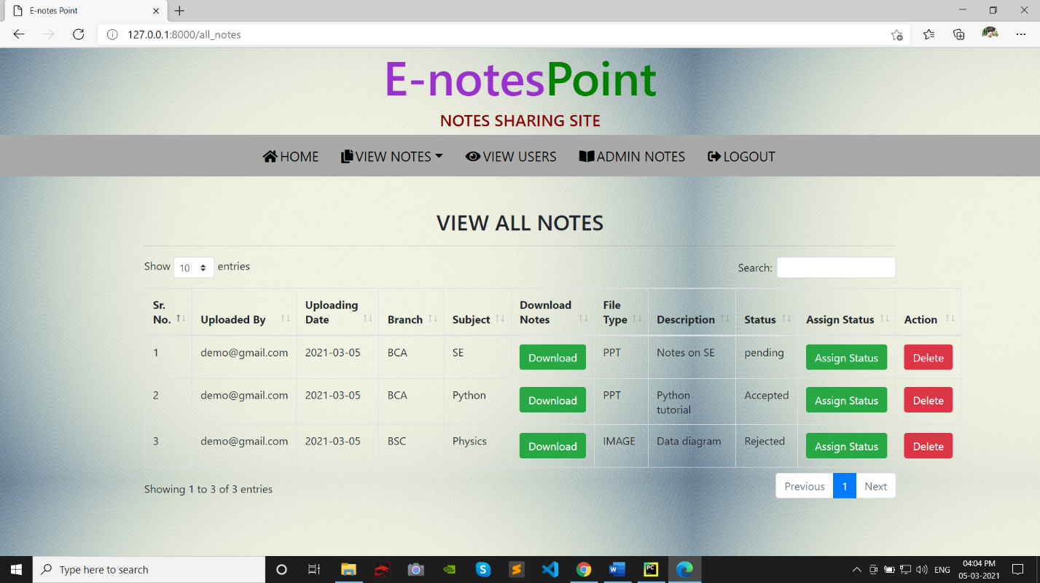

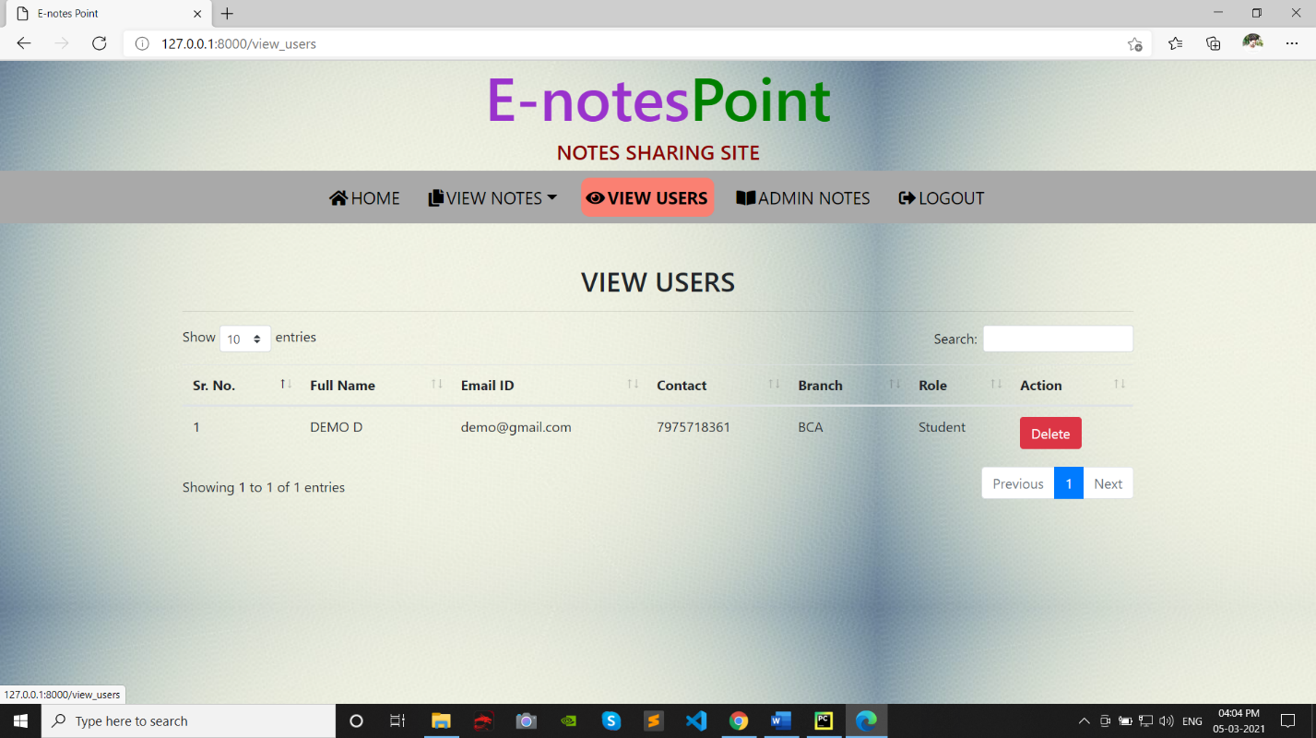

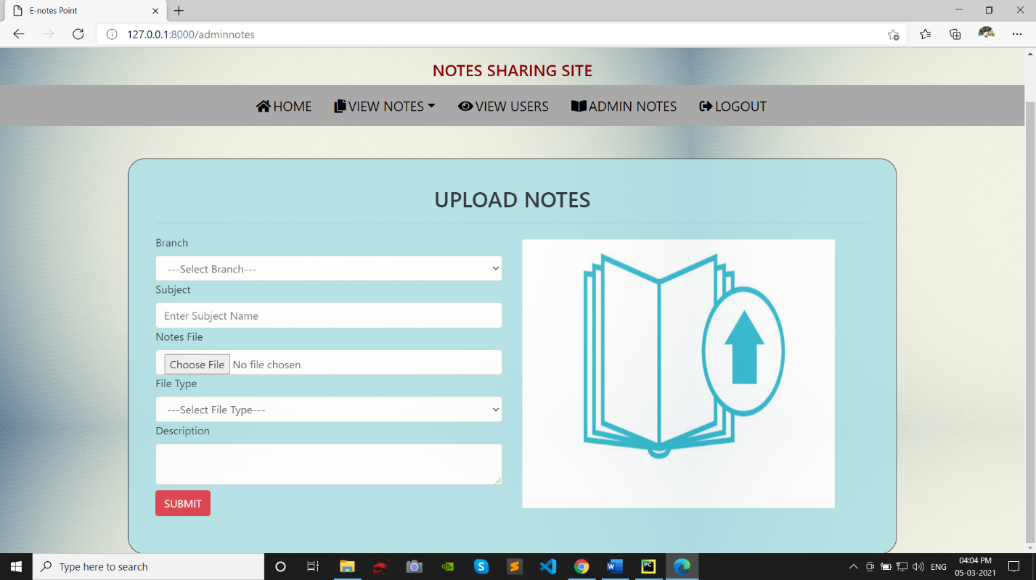

Source Codes

Home page

<html lang=”en”>  
<head>  
 {% load static %}  
 <title>E-notes Point</title>  
  
 <meta charset=”utf-8”>  
 <meta name=”viewport” content=”width=device-width, initial-scale=1”>  
 <link rel=”stylesheet” href=”https://maxcdn.bootstrapcdn.com/bootstrap/4.3.1/css/bootstrap.min.css”>  
 <link rel=”stylesheet” href=”https://use.fontawesome.com/releases/v5.6.3/css/all.css” integrity=”sha384-UHRtZLI+pbxtHCWp1t77Bi1L4ZtiqrqD80Kn4Z8NTSRyMA2Fd33n5dQ8lWUE00s/” crossorigin=”anonymous”></head>  
 <script src=”https://ajax.googleapis.com/ajax/libs/jquery/3.5.1/jquery.min.js”></script>  
 <script src=”https://cdnjs.cloudflare.com/ajax/libs/popper.js/1.16.0/umd/popper.min.js”></script>  
 <script src=”https://maxcdn.bootstrapcdn.com/bootstrap/4.3.1/js/bootstrap.min.js”></script>  
 <link rel=”stylesheet” href=”{%static ‘css/mystyle.css’%}”>  
<body id=”bg” style=”background-image: url(‘{% static ‘images/back1.jpg’ %}’);”>  
<center><h1 style=”font-size:70px” ><span style=”color:Darkorchid”>E-notes</span><span style= “color:green”>Point</span></h1></center>  
<h4 align=”center” style=”color:DarkRed”>NOTES SHARING SITE</h4>  
<nav class=”navbar navbar-expand-sm justify-content-center” style = “background-color : lightgrey”>  
<ul class=”navbar-nav”>  
 <li class=”navbar-item” style=”font-size:20px;”>  
 <a class=”nav-link” href=”{% url ‘index’ %}” ><i class=”fas fa-home” style=”position:relative; right:3px;”></i>HOME</a>  
 </li> &ensp; &ensp;  
 <li class=”navbar-item” style=”font-size:20px;”>  
 <a class=”nav-link” href=”{% url ‘about’ %}”><i class=”fa fa-info-circle” style=”position:relative; right:3px;”></i>ABOUT</a>  
 </li> &ensp; &ensp;  
 <li class=”navbar-item” style=”font-size:20px;”>  
 <a class=”nav-link” href=”{% url ‘contact’ %}”><i class=”fas fa-address-book” style=”position:relative; right:3px;”></i>CONTACT</a>  
 </li> &ensp; &ensp;  
 <li class=”navbar-item” style=”font-size:20px;”>  
 <a class=”nav-link” href=”{% url ‘login’ %}”><i class=”fas fa-sign-in-alt” style=”position:relative; right:3px;”></i>LOGIN</a>  
 </li> &ensp; &ensp;  
 <li class=”navbar-item” style=”font-size:20px;”>  
 <a class=”nav-link” href=”{% url ‘login_admin’ %}”><i class=”fas fa-user-shield” style=”position:relative; right:3px;”></i>ADMIN LOGIN</a>  
 </li>  
  
</ul>  
</nav>  
</body>  
</html>  
  
{% block body %}  
  
{% endblock %}

{% extends ‘navigation.html’ %}  
{% block body %}  
{% load static %}  
<style>  
.image{  
max-width:100%;  
 height:470px;  
background:url({% static ‘images/index3.jpg’ %});  
background-repeat: no-repeat;  
background-attachment:fixed;  
background-position:center ;  
}  
  
</style>  
<div class=”image”>  
<div class=”transparentbox”>  
<p>A book is like a garden that <br>can be carried in your pocket</p>  
</div>  
</div>  
<h4 class=”text-center text-danger mt-5 mb-5”>Just 4 steps to follow</h4>  
<div class=”container mt-5” align=”center”>  
 <div class=”row”>  
 <div class=”col-sm-3”>  
 <div class=”box1”>  
 <p class=”halfcircle”><i class=”text-center fas fa-user-circle text-white mt-4” style=”font-size:40px”></i></p>  
 <p class=”halfcircleBottom” style=”font-size : 20px”>Create Account</p>  
 </div>  
 </div>  
  
 <div class=”col-sm-3”>  
 <div class=”box1”>  
 <p class=”halfcircle”><i class=”text-center fas fa-sign-in-alt text-white mt-4” style=”font-size:40px”></i></p>  
 <p class=”halfcircleBottom” style=”font-size : 20px”>Login</p>  
 </div>  
 </div>  
  
 <div class=”col-sm-3”>  
 <div class=”box1”>  
 <p class=”halfcircle”><i class=”text-center fas fa-upload text-white mt-4” style=”font-size:40px”></i></p>  
 <p class=”halfcircleBottom” style=”font-size : 20px”>Upload Notes</p>  
 </div>  
 </div>  
  
 <div class=”col-sm-3”>  
 <div class=”box1”>  
 <p class=”halfcircle”><i class=”text-center fas fa-download text-white mt-4” style=”font-size:40px”></i></p>  
 <p class=”halfcircleBottom” style=”font-size : 20px”>Download Notes</p>  
 </div>  
 </div>  
 </div>  
</div>  
<br>  
<br>  
  
<style>  
.halfcircle{  
height: 75px;  
width:150px;  
border-radius : 90px 90px 0 0;  
margin:0px;  
background-color : green;  
}  
  
.halfcircleBottom{  
height: 75px;  
width:150px;  
border-radius : 0px 0px 90px 90px;  
margin:0px;  
background-color : darkslategrey;  
}  
</style>  
  
{% endblock %}

About us page

{% extends ‘navigation.html’ %}  
{% load static %}  
{% block body %}  
  
  
<div class=”container”>  
 <img src = “{% static ‘images/aboutus.jpg’ %}” style=”width:90%;height:450px” class=”mt-2”>  
 <hr>  
<p><h1> HELLO USERS</h1><br>  
<h3>Enotes point is an educational website that is an one-stop solution for students.  
 In this era where we are surrounded by technology all around us, its high time the student life gets a touch of technology.  
 Enotes Point enables students to find the notes and download it for free from the website.....</h3><br>  
 <h3>The website is developed by Kaushik and Manoj by using Python, Django and SQLite 3.</h3>  
  
</p>  
</div>  
<br><br>  
{% endblock %}

Contact us page

{% extends ‘navigation.html’ %}  
{% load static %}  
{% block body %}  
<div style = “width :100% ; height:100px”>  
 <h1 class=” container pt-3” align=”center”>Contact Us</h1>  
</div>  
  
<div class=”container mt-5” >  
 <div class=”row” align=”center”>  
 <div class=”col-sm-6”>  
 <iframe src=”https://www.google.com/maps/embed?pb=!1m14!1m8!1m3!1d15554.212012002497!2d77.5782698!3d12.9364259!3m2!1i1024!2i768!4f13.1!3m3!1m2!1s0x0%3A0x907ec9166161d074!2sSurana%20College!5e0!3m2!1sen!2sin!4v1610263721894!5m2!1sen!2sin” width=”500” height=”450” frameborder=”0” style=”border:0;” allowfullscreen=”” aria-hidden=”false” tabindex=”0”></iframe>  
 </div>  
 <div class=”boxs mt-2”>  
 <div class=”col-sm-8 mt-5”>  
 <p></b><i class=”fas fa-envelope”></i><b> Email ID : kaushikbhaskar10@gmail.com <br> &ensp; &ensp; &ensp; &ensp; &ensp; &ensp; &ensp; &ensp;smanojs1998@gmail.com</b></p>  
 <p><i class=”fas fa-phone-square”></i><b> Contact : 7975718360</b></p>  
 <p><i class=”fas fa-address-card”></i><b> Address : South End Circle</b></p>  
 <p><i class=”fas fa-clock”></i><b> Office Hours : 10:00 am to 4:00 pm</b></p>  
 <p><b>FOLLOW US :</b></p>  
 <a href=”https://www.facebook.com/profile.php?id=100006462003542”><i class=”fab fa-facebook-f”></i></a>  
 <a href=”https://instagram.com/kaushik._.bhaskar?igshid=1wjfxy969tpt9”><i class=”fab fa-instagram pl-5” style=”color:red”></i></a>  
 <a href=”https://twitter.com/Manoj19_02?s=09”><i class=”fab fa-twitter pl-5”></i></a>  
 </div>  
 </div>  
 </div>  
</div>  
<br><br>  
  
<style>  
 .boxs {  
 column-gap:10px;  
 border-radius:25px;  
 width:550px;  
 height:420px;  
 margin:10px;  
 display:inline-block;  
 background-color:powderblue;  
 border:1px solid ;  
 opacity:0.9;  
 }  
  
</style>  
{% endblock %}

Login page

{% extends ‘navigation.html’ %}  
{% load static %}  
{% block body %}  
  
{% ifequal error “no” %}  
<script>  
 alert(‘Logged In Successfully’);  
 window.location=(‘{% url ‘profile’ %}’);  
</script>  
{% endifequal %}  
  
{% ifequal error “yes” %}  
<script>  
 alert(‘Invalid Login Credentials , Try Again’);  
</script>  
{% endifequal %}  
  
<div class=”container mt-5”>  
 <div class=”row”>  
 <div class=”boxs mt-5”>  
 <h1 class=”text-center”>NEW USER</h1>  
 <HR>  
 <p style=”text-align : center”><strong>By creating an account with our website, u will be able to <br> move  
 through the notes uploading and downloading <br> process and more...</strong></p>  
 <center><a href=”{% url ‘signup’ %}” class=”btn btn-danger text-white text-center mt-5”>CREATE AN ACCOUNT</a></center>  
 </div>  
 <div class=”boxs mt-5”>  
 <h1 class=”text-center”>USER LOGIN</h1>  
 <HR>  
 <form method=”post”>  
 {% csrf_token %}  
 <label><h5><b>Email Address</b></h5></label>  
 <input type=”email” class=”form-control” placeholder=”Enter Email ID” name=”jango”>  
 <br>  
 <label><h5><b>Password</b></h5></label>  
 <input type=”password” class=”form-control” placeholder=”Enter Password” name=”pwd”>  
 <center><input type=submit class=”btn btn-danger mt-3” value=”LOGIN”></center>  
 </form>  
 </div>  
 </div>  
</div>  
  
<style>  
 .boxs {  
 column-gap:10px;  
 border-radius:25px;  
 width:550px;  
 height:420px;  
 padding:40px;  
 margin:10px;  
 background-color:powderblue;  
 border:1px solid ;  
 opacity:0.9;  
 }  
  
</style>  
  
{% endblock %}

Admin login page

{% extends ‘navigation.html’ %}  
{% load static %}  
{% block body %}  
  
{% ifequal error “no” %}  
<script>  
 alert(‘Logged In Successfully’);  
 window.location=(‘{% url ‘admin_home’ %}’);  
</script>  
{% endifequal %}  
  
{% ifequal error “yes” %}  
<script>  
 alert(‘Invalid Login Credentials , Try Again’);  
</script>  
{% endifequal %}  
  
<div class=”container mt-5”>  
 <div class=”row”>  
 <div class=”col-sm-5”>  
 <img src=”{% static ‘images/adminloginn.jpg’ %}” class=”image-thumbnail my-3” style=”width:80% ; height : 345px” >  
 </div>  
 <div class=”col-sm-6”>  
 <h2 class=”text-center”>ADMIN LOGIN</h2>  
 <HR>  
 <P><b>Enter Your UserName and Password for accessing Admin Panel</b></P>  
  
  
 <form method=”post”>  
 {% csrf_token %}  
 <label><h5><b>User Name</b></h5></b></label>  
 <input type=”text” class=”form-control” placeholder=”Enter UserName” name=”uname”>  
 <br>  
 <label><h5><b>Password</b></h5></b></label>  
 <input type=”password” class=”form-control” placeholder=”Enter Password” name=”pwd”>  
 <input type=submit class=”btn btn-primary mt-2” value=”LOGIN”>  
 </form>  
 </div>  
 </div>  
</div>  
  
<style>  
 .col-sm-6 {  
 border-radius:25px;  
 width:1135px;  
 height:450px;  
 padding:40px;  
 background-color:powderblue;  
 border:1px solid ;  
 opacity:0.9;  
  
 }  
 }  
  
</style>  
{% endblock %}

Create user page

{% extends ‘navigation.html’ %}  
{% load static %}  
{% block body %}  
  
<div class=”container mt-5”>  
 <div class=”row”>  
 <div class=”col-sm-5”>  
  
 <div align=”center” class=”create”>  
 <img src = “{% static ‘images/newuser.png’ %}” STYLE=”WIDTH:80% ; height:420px”>  
 </div>  
  
 </div>  
 <div class=”col-sm-6”>  
 <h2 class=”text-center”>REGISTER WITH US</h2>  
 <HR>  
 <p><b>If you have not yet got an account with us, please signup</b></p>  
 <form method=”post”>  
 {% csrf_token %}  
 <label><b>FirstName* &ensp; (Enter alphabets only) </b></label>  
 <input pattern=”[a-zA-Z]+” class=”form-control” name=”firstname” placeholder=”ENTER FIRST NAME” required style=”text-transform:uppercase” type=”text”>  
 <label><b>LastName* &ensp; (Enter alphabets only) </b></label>  
 <input pattern=”[a-zA-Z]+” class=”form-control” name=”lastname” required placeholder=”ENTER LAST NAME” style=”text-transform:uppercase” type=”text”>  
 <label><b>Contact* &ensp; (Enter numbers only)</b></label>  
 <input class=”form-control” name=”contact” pattern=”[0-9]{10}” placeholder=”ENTER CONTACT NUMBER” required type=”text”>  
 <label><b>Email ID*</b></label>  
 <input type=”email” class=”form-control” placeholder=”ENTER YOUR EMAIL ID” name=”jango”>  
 <label><b>Password* &ensp; (minimum 8 characters required) </b></label>  
 <input class=”form-control” name=”password” pattern=”.{8,}” placeholder=”ENTER PASSWORD” required type=”Password”>  
 <label><b>Branch*</b></label>  
 <select class=”form-control” name=”branch”>  
 <option value=”BCA”>BCA</option>  
 <option value=”BSC”>BSC</option>  
 <option value=”BBA”>BBA</option>  
 <option value=”B.Com”>B.Com</option>  
 <option value=”MCA”>MCA</option>  
 </select>  
 <label><b>Are You?*</b></label>  
 <select class=”form-control” name=”role”>  
 <option value=”Student”>Student</option>  
 <option value=”Teacher”>Teacher</option>  
 </select>  
 <input type=submit class=”btn btn-danger mt-2” value=”SUBMIT”>  
 </form>  
 </div>  
 </div>  
</div>  
  
{% ifequal error “no” %}  
<script>  
 alert(‘Signup Successful’);  
 window.location=(‘{% url ‘login’ %}’);  
</script>  
{% endifequal %}  
  
{% ifequal error “yes” %}  
<script>  
 alert(‘Something Went Wrong , Try Again’);  
</script>  
{% endifequal %}  
  
<style>  
.create{  
padding-top:150px;  
}  
.col-sm-6{  
background-color:powderblue;  
 border:1px solid ;  
 border-radius:25px;  
 padding:40px;  
 opacity:0.9;  
  
}  
</style>  
  
{% endblock %}

Profile page

<html lang=”en”>  
<head>  
 {% load static %}  
 <title>E-notes Point</title>  
 <meta charset=”utf-8”>  
 <meta name=”viewport” content=”width=device-width, initial-scale=1”>  
 <link rel=”stylesheet” href=”https://maxcdn.bootstrapcdn.com/bootstrap/4.3.1/css/bootstrap.min.css”>  
 <link rel=”stylesheet” href=”https://use.fontawesome.com/releases/v5.6.3/css/all.css” integrity=”sha384-UHRtZLI+pbxtHCWp1t77Bi1L4ZtiqrqD80Kn4Z8NTSRyMA2Fd33n5dQ8lWUE00s/” crossorigin=”anonymous”></head>  
 <script src=”https://ajax.googleapis.com/ajax/libs/jquery/3.5.1/jquery.min.js”></script>  
 <script src=”https://cdnjs.cloudflare.com/ajax/libs/popper.js/1.16.0/umd/popper.min.js”></script>  
 <script src=”https://maxcdn.bootstrapcdn.com/bootstrap/4.3.1/js/bootstrap.min.js”></script>  
 <link rel=”stylesheet” href=”{%static ‘css/mystyle.css’%}”>  
<body>  
<center><h1 style=”font-size:70px” ><span style=”color:Darkorchid”>E-notes</span><span style= “color:green”>Point</span></h1></center>  
<h4 align=”center” style=”color:DarkRed”>NOTES SHARING SITE</h4>  
<nav class=”navbar navbar-expand-sm justify-content-center” style = “background-color : darkgrey”>  
<ul class=”navbar-nav”>  
 <li class=”navbar-item” style=”font-size:20px;”>  
 <a class=”nav-link” href=”{% url ‘profile’ %}”><i class=”fas fa-user” style=”position:relative; right:3px;”></i>PROFILE</a>  
 </li> &ensp; &ensp;  
 <li class=”navbar-item” style=”font-size:20px;”>  
 <a class=”nav-link” href=”{% url ‘upload_notes’ %}”><i class=”fas fa-file-upload” style=”position:relative; right:3px;”></i>UPLOAD NOTES</a>  
 </li> &ensp; &ensp;  
 <li class=”navbar-item” style=”font-size:20px;”>  
 <a class=”nav-link” href=”{% url ‘view_mynotes’ %}”><i class=”fas fa-sticky-note” style=”position:relative; right:3px;”></i>VIEW MY NOTES</a>  
 </li> &ensp; &ensp;  
 <li class=”navbar-item” style=”font-size:20px;”>  
 <a class=”nav-link” href=”{% url ‘viewallnotes’ %}”><i class=”fas fa-copy” style=”position:relative; right:3px;”></i>VIEW ALL NOTES</a>  
 </li> &ensp; &ensp;  
 <li class=”navbar-item” style=”font-size:20px;”>  
 <a class=”nav-link” href=”{% url ‘logout’ %}”><i class=”fas fa-sign-out-alt” style=”position:relative; right:3px;”></i>LOGOUT</a>  
 </li> &ensp; &ensp;  
  
<div class=”btn-group”>  
 <button type=”button” class=”btn btn-primary dropdown-toggle” data-toggle=”dropdown” style=”font-size:20px;”>Welcome {{request.user.first_name}}</button>  
 <div class=”dropdown-menu”>  
 <a class=”dropdown-item” href=”{% url ‘edit_profile’ %}”>EDIT PROFILE</a>  
 <a class=”dropdown-item” href=”{% url ‘changepassword’ %}”>CHANGE PASSWORD</a>  
  
 </div>  
</div>  
</ul>  
</nav>  
</body>  
</html>  
  
{% block body %}  
{% endblock %}

{% extends ‘usernavigation.html’ %}  
{% load static %}  
{% block body %}  
<body id=”bg” style=”background-image: url(‘{% static ‘images/back1.jpg’ %}’);”>  
<div class=”container mt-5”>  
 <h2 class=”text-center”>PROFILE</h2>  
 <HR>  
 <div class=”row”>  
 <div class=”col-md-6”>  
 <b>Full Name:</b>  
  
 </div>  
 <div class=”col-md-6”>  
 {{data.user.first_name}} {{data.user.last_name}}  
 </div>  
 </div>  
<hr>  
 <div class=”row”>  
 <div class=”col-md-6”>  
 <b>Email ID :</b>  
  
 </div>  
 <div class=”col-md-6”>  
 {{data.user.username}}  
 </div>  
 </div>  
  
<hr>  
 <div class=”row”>  
 <div class=”col-md-6”>  
 <b>Contact :</b>  
  
 </div>  
 <div class=”col-md-6”>  
 {{data.contact}}  
 </div>  
 </div>  
  
<hr>  
 <div class=”row”>  
 <div class=”col-md-6”>  
 <b>Branch :</b>  
  
 </div>  
 <div class=”col-md-6”>  
 {{data.branch}}  
 </div>  
 </div>  
  
 <center><a href=”{% url ‘edit_profile’ %}” class=”btn btn-primary mt-5”>Edit Profile</a></center>  
  
</div>  
<style>  
 .container {  
 background-color:powderblue;  
 border:1px solid ;  
 opacity:0.9;  
 border-radius:25px;  
 width:700px;  
 height:500px;  
 padding:40px;  
 }  
</style>  
</body>  
{% endblock %}

Upload notes page

{% extends ‘usernavigation.html’ %}  
{% load static %}  
{% block body %}  
<body id=”bg” style=”background-image: url(‘{% static ‘images/back1.jpg’ %}’);”>  
<div class=”container mt-5”>  
 <h2 class=”text-center”>UPLOAD NOTES</h2>  
 <HR>  
<div class=”row”>  
 <div class=”col-sm-6”>  
 <form method=”post” enctype=”multipart/form-data”>  
 {% csrf_token %}  
 <label>Branch</label>  
 <select class=”form-control” name=”branch”>  
 <option value=””>---Select Branch---</option>  
 <option value=”BCA”>BCA</option>  
 <option value=”BSC”>BSC</option>  
 <option value=”BBA”>BBA</option>  
 <option value=”B.Com”>B.Com</option>  
 <option value=”MCA”>MCA</option>  
 </select>  
  
 <label>Subject</label>  
 <input type=”text” class=”form-control” placeholder=”Enter Subject Name” name=”subject”>  
 <label>Notes File</label>  
 <input type=”file” class=”form-control” name=”notesfile”>  
 <label>File Type</label>  
 <select class=”form-control” name=”filetype”>  
 <option value=””>---Select File Type---</option>  
 <option value=”PDF”>PDF</option>  
 <option value=”PPT”>PPT</option>  
 <option value=”DOC/DOCX”>DOC/DOCX</option>  
 <option value=”TXT”>TXT</option>  
 <option value=”IMAGE”>IMAGE</option>  
 <option value=”ZIP/RAR”>ZIP/RAR</option>  
 </select>  
  
  
 <label>Description</label>  
 <textarea class=”form-control” name=”description”>  
  
 </textarea>  
 <input type=submit class=”btn btn-danger mt-2” value=”SUBMIT”>  
 </form>  
 </div>  
  
 <div class=”col-sm-6”>  
 <img src=”{% static ‘images/upload.jpg’%}” style =”width:90%;height:400px” class=”mt-2”>  
 </div>  
</div>  
</div>  
{% ifequal error “no” %}  
<script>  
 alert(‘Notes Uploaded Successfully’);  
  
</script>  
{% endifequal %}  
  
{% ifequal error “yes” %}  
<script>  
 alert(‘Something Went Wrong , Try Again’);  
</script>  
{% endifequal %}  
</body>  
<style>  
.container{  
 background-color:powderblue;  
 border:1px solid ;  
 border-radius:25px;  
 padding:40px;  
 opacity:0.9;  
}  
</style>  
{% endblock %}

View My notes page

{% extends ‘usernavigation.html’ %}  
{% load static %}  
{% block body %}  
<body id=”bg” style=”background-image: url(‘{% static ‘images/back1.jpg’ %}’);”>  
<script src=”https://code.jquery.com/jquery-3.5.1.js”></script>  
<script src=”https://cdn.datatables.net/1.10.23/js/jquery.dataTables.min.js”></script>  
<script src=”https://cdn.datatables.net/1.10.23/js/dataTables.bootstrap4.min.js”></script>  
  
<link rel= “stylesheet” href=”https://cdnjs.cloudflare.com/ajax/libs/twitter-bootstrap/4.5.2/css/bootstrap.css”>  
<link rel= “stylesheet” href=”https://cdn.datatables.net/1.10.23/css/dataTables.bootstrap4.min.css”>  
  
<script>  
$(document).ready(function() {  
 $(‘#example’).DataTable();  
} );  
</script>  
<div class=”container mt-5”>  
 <h2 class=”text-center”>VIEW MY NOTES</h2>  
 <HR>  
  
 <table class=”table table=bordered” id=”example”>  
 <thead>  
 <tr>  
 <th>Sr. No.</th>  
 <th>Uploading Date</th>  
 <th>Branch</th>  
 <th>Subject</th>  
 <th>Download Notes</th>  
 <th>File Type</th>  
 <th>Description</th>  
 <th>Status</th>  
 <th>Action</th>  
 </tr>  
 </thead>  
 <tbody>  
 {% for i in notes %}  
 <tr>  
 <td>{{forloop.counter}}</td>  
 <td>{{i.uploadingdate}}</td>  
 <td>{{i.branch}}</td>  
 <td>{{i.subject}}</td>  
 <td><a href=”{{i.notesfile.url}}” class=”btn btn-success” download>Download</a></td>  
 <td>{{i.filetype}}</td>  
 <td>{{i.description}}</td>  
 <td>{{i.status}}</td>  
 <td><a href=”{% url ‘delete_mynotes’ i.id %}” class=”btn btn-danger” onclick=”return confirm(‘Are you sure?’)”>Delete</a></td>  
 </tr>  
 {% endfor %}  
 </tbody>  
 </table>  
  
</div>  
</body>  
{% endblock %}

View all notes page

{% extends ‘admin_nav.html’ %}  
{% load static %}  
{% block body %}  
<body id=”bg” style=”background-image: url(‘{% static ‘images/back1.jpg’ %}’);”>  
<script src=”https://code.jquery.com/jquery-3.5.1.js”></script>  
<script src=”https://cdn.datatables.net/1.10.23/js/jquery.dataTables.min.js”></script>  
<script src=”https://cdn.datatables.net/1.10.23/js/dataTables.bootstrap4.min.js”></script>  
  
<link rel= “stylesheet” href=”https://cdnjs.cloudflare.com/ajax/libs/twitter-bootstrap/4.5.2/css/bootstrap.css”>  
<link rel= “stylesheet” href=”https://cdn.datatables.net/1.10.23/css/dataTables.bootstrap4.min.css”>  
  
<script>  
$(document).ready(function() {  
 $(‘#example’).DataTable();  
} );  
</script>  
<div class=”container mt-5”>  
 <h2 class=”text-center”>VIEW ALL NOTES</h2>  
 <HR>  
  
 <table class=”table table-bordered” id=”example”>  
 <thead>  
 <tr>  
 <th>Sr. No.</th>  
 <th>Uploaded By</th>  
 <th>Uploading Date</th>  
 <th>Branch</th>  
 <th>Subject</th>  
 <th>Download Notes</th>  
 <th>File Type</th>  
 <th>Description</th>  
 <th>Status</th>  
 <th>Assign Status</th>  
 <th>Action</th>  
 </tr>  
 </thead>  
 <tbody>  
 {% for i in notes %}  
 <tr>  
 <td>{{forloop.counter}}</td>  
 <td>{{i.user.username}}</td>  
 <td>{{i.uploadingdate}}</td>  
 <td>{{i.branch}}</td>  
 <td>{{i.subject}}</td>  
 <td><a href=”{{i.notesfile.url}}” class=”btn btn-success” download>Download</a></td>  
 <td>{{i.filetype}}</td>  
 <td>{{i.description}}</td>  
 <td>{{i.status}}</td>  
 <td><a href=”{% url ‘assign_status’ i.id %}” class=”btn btn-success”>Assign&nbsp;Status</a></td>  
  
 <td><a href=”{% url ‘delete_notes’ i.id %}” class=”btn btn-danger” onclick=”return confirm(‘Are you sure?’)”>Delete</a></td>  
 </tr>  
 {% endfor %}  
 </tbody>  
 </table>  
  
</div>  
</body>  
{% endblock %}

Edit profile page

{% extends ‘usernavigation.html’ %}  
{% load static %}  
{% block body %}  
<body id=”bg” style=”background-image: url(‘{% static ‘images/back1.jpg’ %}’);”>  
<div class=”container mt-5” >  
 <div class=”row”>  
 <div class=”col-sm-12”>  
 <h2 class=”text-center”>EDIT PROFILE</h2>  
 <HR>  
 <form method=”post”>  
 {% csrf_token %}  
 <div class=”form-row”>  
 <div class=”form-group col-sm-6”>  
 <label><b>FirstName</b></label>  
 <input type=”text” class=”form-control” value=”{{data.user.first_name}}” name=”firstname”>  
 </div>  
 <div class=”form-group col-sm-6”>  
 <label><b>LastName</b></label>  
 <input type=”text” class=”form-control” value=”{{data.user.last_name}}” name=”lastname”>  
 </div>  
 </div>  
  
 <div class=”form-row”>  
 <div class=”form-group col-md-12”>  
 <label><b>Email ID</b></label>  
 <input type=”text” class=”form-control” value=”{{data.user.username}}” name=”jango” readonly>  
 </div>  
 </div>  
  
 <div class=”form-row”>  
 <div class=”form-group col-md-12”>  
 <label><b>Contact</b></label>  
 <input type=”text” class=”form-control” value=”{{data.contact}}” name=”contact”>  
 </div>  
 </div>  
  
 <div class=”form-row”>  
 <div class=”form-group col-md-6”>  
 <label><b>Branch</b></label>  
 <select class=”form-control” name=”branch”>  
 <option value=”BCA”>BCA</option>  
 <option value=”BSC”>BSC</option>  
 <option value=”BBA”>BBA</option>  
 <option value=”B.Com”>B.Com</option>  
 <option value=”MCA”>MCA</option>  
 </select>  
 </div>  
 <div class=”form-group col-md-6 mt-2”>  
 <br>  
 <input type=”text” value=”{{data.branch}}” class=”form-control” readonly>  
 </div>  
 </div>  
<center><input type=”submit” value=”Update” class=”btn btn-primary mt-3”></center>  
 </form>  
 </div>  
 </div>  
  
  
  
</div>  
  
{% if error %}  
<script>  
 alert(‘Profile Updated Successfully’);  
 window.location = “{% url ‘profile’ %}”;  
</script>  
{% endif %}  
<style>  
 .container {  
 background-color:powderblue;  
 border:1px solid ;  
 opacity:0.9;  
 border-radius:25px;  
 width:600px;  
  
 }  
</style>  
</body>  
{% endblock %}

Change password page

{% extends ‘usernavigation.html’ %}  
{% load static %}  
{% block body %}  
  
{% ifequal error “no” %}  
<script>  
 alert(‘Password Changed..’);  
 window.location=(‘{% url ‘logout’ %}’);  
</script>  
{% endifequal %}  
  
{% ifequal error “yes” %}  
<script>  
 alert(‘Invalid Login Credentials , Try Again’);  
</script>  
{% endifequal %}  
<body id=”bg” style=”background-image: url(‘{% static ‘images/back1.jpg’ %}’);”>  
<div class=”container mt-5”>  
 <div class=”row”>  
 <div class=”col-sm-6”>  
 <img src = “{% static ‘images/changepwd.jpg’ %}” STYLE=”WIDTH:90% ; height:400px”>  
 </div>  
 <div class=”col-sm-6”>  
 <h2 class=”text-center”>CHANGE PASSWORD</h2>  
 <HR>  
 <form method=”post”>  
 {% csrf_token %}  
 <label><b>Old Password* &ensp; (minimum 8 characters required)</b></label>  
 <input class=”form-control” name=”old” pattern=”.{8,}” placeholder=”ENTER OLD PASSWORD” required type=”Password”>  
 <label><b>New Password* &ensp; (minimum 8 characters required)</b></label>  
 <input class=”form-control” name=”new” pattern=”.{8,}” placeholder=”ENTER NEW PASSWORD” required type=”Password”>  
 <label><b>Re-Enter New Password* &ensp; (minimum 8 characters required)</b></label>  
 <input class=”form-control” name=”confirm” pattern=”.{8,}” placeholder=”RE-ENTER NEW PASSWORD” required type=”Password”>  
 <input type=submit class=”btn btn-danger mt-2” value=”SUBMIT”>  
  
 </form>  
 </div>  
 </div>  
</div>  
</body>  
<style>  
 .container {  
 background-color:powderblue;  
 border:1px solid ;  
 opacity:0.9;  
 border-radius:25px;  
 width:1000px;  
 height:500px;  
 padding:40px;  
  
 }  
</style>  
  
{% endblock %}

Admin home page

<html lang=”en”>  
<head>  
 {% load static %}  
 <title>E-notes Point</title>  
 <meta charset=”utf-8”>  
 <meta name=”viewport” content=”width=device-width, initial-scale=1”>  
 <link rel=”stylesheet” href=”https://maxcdn.bootstrapcdn.com/bootstrap/4.3.1/css/bootstrap.min.css”>  
 <link rel=”stylesheet” href=”https://use.fontawesome.com/releases/v5.6.3/css/all.css” integrity=”sha384-UHRtZLI+pbxtHCWp1t77Bi1L4ZtiqrqD80Kn4Z8NTSRyMA2Fd33n5dQ8lWUE00s/” crossorigin=”anonymous”></head>  
 <script src=”https://ajax.googleapis.com/ajax/libs/jquery/3.5.1/jquery.min.js”></script>  
 <script src=”https://cdnjs.cloudflare.com/ajax/libs/popper.js/1.16.0/umd/popper.min.js”></script>  
 <script src=”https://maxcdn.bootstrapcdn.com/bootstrap/4.3.1/js/bootstrap.min.js”></script>  
 <link rel=”stylesheet” href=”{%static ‘css/mystyle.css’%}”>  
<body>  
<center><h1 style=”font-size:70px” ><span style=”color:Darkorchid”>E-notes</span><span style= “color:green”>Point</span></h1></center>  
<h4 align=”center” style=”color:DarkRed”>NOTES SHARING SITE</h4>  
<nav class=”navbar navbar-expand-sm justify-content-center” style = “background-color : darkgrey”>  
<ul class=”navbar-nav”>  
 <li class=”navbar-item” style=”font-size:20px;”>  
 <a class=”nav-link” href=”{% url ‘admin_home’ %}”><i class=”fas fa-home” style=”position:relative; right:3px;”></i>HOME</a>  
 </li> &ensp; &ensp;  
 <li class=”nav-item dropdown” style=”font-size:20px;”>  
 <a class=”nav-link dropdown-toggle” href=”#” data-toggle=”dropdown”><i class=”fas fa-copy” style=”position:relative; right:3px;”></i>VIEW NOTES</a>  
  
 <div class=”dropdown-menu” style=”font-size:20px;”>  
 <a class=”dropdown-item” href=”{% url ‘pending_notes’ %}”>PENDING</a>  
 <a class=”dropdown-item” href=”{% url ‘accepted_notes’ %}”>ACCEPTED</a>  
 <a class=”dropdown-item” href=”{% url ‘rejected_notes’ %}”>REJECTED</a>  
 <a class=”dropdown-item” href=”{% url ‘all_notes’ %}”>ALL NOTES</a>  
 </div>  
  
 </li> &ensp; &ensp;  
 <li class=”navbar-item” style=”font-size:20px;”>  
 <a class=”nav-link” href=”{% url ‘view_users’ %}”><i class=”fas fa-eye” style=”position:relative; right:3px;”></i>VIEW USERS</a>  
 </li> &ensp; &ensp;  
 <li class=”navbar-item” style=”font-size:20px;”>  
 <a class=”nav-link” href=”{% url ‘adminnotes’ %}”><i class=”fas fa-book-open” style=”position:relative; right:3px;”></i>ADMIN NOTES</a>  
 </li> &ensp; &ensp;  
 <li class=”navbar-item” style=”font-size:20px;”>  
 <a class=”nav-link” href=”{% url ‘logout’ %}”><i class=”fas fa-sign-out-alt” style=”position:relative; right:3px;”></i>LOGOUT</a>  
 </li>  
  
</ul>  
  
</nav>  
  
</body>  
</html>  
  
{% block body %}  
{% endblock %}

{% extends ‘admin_nav.html’ %}  
{% load static %}  
{% block body %}  
  
<style>  
.container1{  
background-color : lightgrey;  
border-radius : 8px;  
}  
  
h2,h4{padding : 10px}  
  
.mydiv:hover{  
transform:jangote(-10px)  
}  
</style>  
<body id=”bg” style=”background-image: url(‘{% static ‘images/back1.jpg’ %}’);”>  
<br>  
<br>  
<div align=”center”>  
<img src = “{% static ‘images/adminbook.png’ %}” STYLE=”WIDTH:30% ; height:300px”>  
</div>  
<br>  
<div class=”container mt-5”>  
 <div class=”row”>  
 <div class=”col-sm-3 text-center mydiv”>  
 <div class=”container1”>  
 <h2 class=”text-primary”>{{pn}}</h2>  
 <a href=”{% url ‘pending_notes’ %}”><h4 class=”text-dark”>Pending Notes</h4></a>  
 </div>  
 </div>  
  
  
  
<div class=”col-sm-3 text-center mydiv”>  
 <div class=”container1”>  
 <h2 class=”text-primary”>{{an}}</h2>  
 <a href=”{% url ‘accepted_notes’ %}”><h4 class=”text-dark”>Accepted Notes</h4></a>  
 </div>  
 </div>  
  
  
<div class=”col-sm-3 text-center mydiv”>  
 <div class=”container1”>  
 <h2 class=”text-primary”>{{rn}}</h2>  
 <a href=”{% url ‘rejected_notes’ %}”><h4 class=”text-dark”>Rejected Notes</h4></a>  
 </div>  
 </div>  
  
  
<div class=”col-sm-3 text-center mydiv”>  
 <div class=”container1”>  
 <h2 class=”text-primary”>{{alln}}</h2>  
 <a href=”{% url ‘all_notes’ %}”><h4 class=”text-dark”>All Notes</h4></a>  
 </div>  
 </div>  
  
 </div>  
</div>  
  
</body>  
{% endblock %}

Pending Notes page

{% extends ‘admin_nav.html’ %}  
{% load static %}  
{% block body %}  
<body id=”bg” style=”background-image: url(‘{% static ‘images/back1.jpg’ %}’);”>  
<script src=”https://code.jquery.com/jquery-3.5.1.js”></script>  
<script src=”https://cdn.datatables.net/1.10.23/js/jquery.dataTables.min.js”></script>  
<script src=”https://cdn.datatables.net/1.10.23/js/dataTables.bootstrap4.min.js”></script>  
  
<link rel= “stylesheet” href=”https://cdnjs.cloudflare.com/ajax/libs/twitter-bootstrap/4.5.2/css/bootstrap.css”>  
<link rel= “stylesheet” href=”https://cdn.datatables.net/1.10.23/css/dataTables.bootstrap4.min.css”>  
  
<script>  
$(document).ready(function() {  
 $(‘#example’).DataTable();  
} );  
</script>  
<div class=”container mt-5” >  
 <h2 class=”text-center”>VIEW PENDING NOTES</h2>  
 <HR>  
  
 <table class=”table table=bordered” id=”example” >  
 <thead>  
 <tr>  
 <th>Sr. No.</th>  
 <th>Uploaded By</th>  
 <th>Uploading Date</th>  
 <th>Branch</th>  
 <th>Subject</th>  
 <th>Download Notes</th>  
 <th>File Type</th>  
 <th>Description</th>  
 <th>Status</th>  
 <th>Assign Status</th>  
 <th>Action</th>  
 </tr>  
 </thead>  
 <tbody>  
 {% for i in notes %}  
 <tr>  
 <td>{{forloop.counter}}</td>  
 <td>{{i.user.username}}</td>  
 <td>{{i.uploadingdate}}</td>  
 <td>{{i.branch}}</td>  
 <td>{{i.subject}}</td>  
 <td><a href=”{{i.notesfile.url}}” class=”btn btn-success” download>Download</a></td>  
 <td>{{i.filetype}}</td>  
 <td>{{i.description}}</td>  
 <td>{{i.status}}</td>  
 <td><a href=”{% url ‘assign_status’ i.id %}” class=”btn btn-success”>Assign&nbsp;Status</a></td>  
  
 <td><a href=”{% url ‘delete_notes’ i.id %}” class=”btn btn-danger” onclick=”return confirm(‘Are you sure?’)”>Delete</a></td>  
 </tr>  
 {% endfor %}  
 </tbody>  
 </table>  
  
</div>  
  
<style>  
.container{  
padding:auto;  
margin:auto;  
text-align:centre  
}  
</style>  
</body>  
{% endblock %}

Accepted note page

{% extends ‘admin_nav.html’ %}  
{% load static %}  
{% block body %}  
  
<script src=”https://code.jquery.com/jquery-3.5.1.js”></script>  
<script src=”https://cdn.datatables.net/1.10.23/js/jquery.dataTables.min.js”></script>  
<script src=”https://cdn.datatables.net/1.10.23/js/dataTables.bootstrap4.min.js”></script>  
  
<link rel= “stylesheet” href=”https://cdnjs.cloudflare.com/ajax/libs/twitter-bootstrap/4.5.2/css/bootstrap.css”>  
<link rel= “stylesheet” href=”https://cdn.datatables.net/1.10.23/css/dataTables.bootstrap4.min.css”>  
  
<script>  
$(document).ready(function() {  
 $(‘#example’).DataTable();  
} );  
</script>  
<body id=”bg” style=”background-image: url(‘{% static ‘images/back1.jpg’ %}’);”>  
<div class=”container mt-5”>  
 <h2 class=”text-center”>VIEW ACCEPTED NOTES</h2>  
 <HR>  
  
 <table class=”table table=bordered” id=”example” >  
 <thead>  
 <tr>  
 <th>Sr. No.</th>  
 <th>Uploaded By</th>  
 <th>Uploading Date</th>  
 <th>Branch</th>  
 <th>Subject</th>  
 <th>Download Notes</th>  
 <th>File Type</th>  
 <th>Description</th>  
 <th>Status</th>  
 <th>Assign Status</th>  
 <th>Action</th>  
 </tr>  
 </thead>  
 <tbody>  
 {% for i in notes %}  
 <tr>  
 <td>{{forloop.counter}}</td>  
 <td>{{i.user.username}}</td>  
 <td>{{i.uploadingdate}}</td>  
 <td>{{i.branch}}</td>  
 <td>{{i.subject}}</td>  
 <td><a href=”{{i.notesfile.url}}” class=”btn btn-success” download>Download</a></td>  
 <td>{{i.filetype}}</td>  
 <td>{{i.description}}</td>  
 <td>{{i.status}}</td>  
 <td><a href=”{% url ‘assign_status’ i.id %}” class=”btn btn-success”>Assign&nbsp;Status</a></td>  
  
 <td><a href=”{% url ‘delete_notes’ i.id %}” class=”btn btn-danger” onclick=”return confirm(‘Are you sure?’)”>Delete</a></td>  
 </tr>  
 {% endfor %}  
 </tbody>  
 </table>  
  
</div>  
  
<style>  
.container{  
padding:auto;  
margin:auto;  
text-align:centre  
}  
</style>  
</body>  
{% endblock %}

Rejected notes page

{% extends ‘admin_nav.html’ %}  
{% load static %}  
{% block body %}  
<body id=”bg” style=”background-image: url(‘{% static ‘images/back1.jpg’ %}’);”>  
<script src=”https://code.jquery.com/jquery-3.5.1.js”></script>  
<script src=”https://cdn.datatables.net/1.10.23/js/jquery.dataTables.min.js”></script>  
<script src=”https://cdn.datatables.net/1.10.23/js/dataTables.bootstrap4.min.js”></script>  
  
<link rel= “stylesheet” href=”https://cdnjs.cloudflare.com/ajax/libs/twitter-bootstrap/4.5.2/css/bootstrap.css”>  
<link rel= “stylesheet” href=”https://cdn.datatables.net/1.10.23/css/dataTables.bootstrap4.min.css”>  
  
<script>  
$(document).ready(function() {  
 $(‘#example’).DataTable();  
} );  
</script>  
<div class=”container mt-5”>  
 <h2 class=”text-center”>VIEW REJECTED NOTES</h2>  
 <HR>  
  
 <table class=”table table=bordered” id=”example”>  
 <thead>  
 <tr>  
 <th>Sr. No.</th>  
 <th>Uploaded By</th>  
 <th>Uploading Date</th>  
 <th>Branch</th>  
 <th>Subject</th>  
 <th>Download Notes</th>  
 <th>File Type</th>  
 <th>Description</th>  
 <th>Status</th>  
 <th>Assign Status</th>  
 <th>Action</th>  
 </tr>  
 </thead>  
 <tbody>  
 {% for i in notes %}  
 <tr>  
 <td>{{forloop.counter}}</td>  
 <td>{{i.user.username}}</td>  
 <td>{{i.uploadingdate}}</td>  
 <td>{{i.branch}}</td>  
 <td>{{i.subject}}</td>  
 <td><a href=”{{i.notesfile.url}}” class=”btn btn-success” download>Download</a></td>  
 <td>{{i.filetype}}</td>  
 <td>{{i.description}}</td>  
 <td>{{i.status}}</td>  
 <td><a href=”{% url ‘assign_status’ i.id %}” class=”btn btn-success”>Assign&nbsp;Status</a></td>  
  
 <td><a href=”{% url ‘delete_notes’ i.id %}” class=”btn btn-danger” onclick=”return confirm(‘Are you sure?’)”>Delete</a></td>  
 </tr>  
 {% endfor %}  
 </tbody>  
 </table>  
  
</div>  
  
<style>  
.container{  
padding:auto;  
margin:auto;  
text-align:centre  
}  
</style>  
</body>  
{% endblock %}

View Users page

{% extends ‘admin_nav.html’ %}  
{% load static %}  
{% block body %}  
<body id=”bg” style=”background-image: url(‘{% static ‘images/back1.jpg’ %}’);”>  
<script src=”https://code.jquery.com/jquery-3.5.1.js”></script>  
<script src=”https://cdn.datatables.net/1.10.23/js/jquery.dataTables.min.js”></script>  
<script src=”https://cdn.datatables.net/1.10.23/js/dataTables.bootstrap4.min.js”></script>  
  
<link rel= “stylesheet” href=”https://cdnjs.cloudflare.com/ajax/libs/twitter-bootstrap/4.5.2/css/bootstrap.css”>  
<link rel= “stylesheet” href=”https://cdn.datatables.net/1.10.23/css/dataTables.bootstrap4.min.css”>  
  
<script>  
$(document).ready(function() {  
 $(‘#example’).DataTable();  
} );  
</script>  
  
<div class=”container mt-5”>  
 <h2 class=”text-center”>VIEW USERS</h2>  
 <HR>  
  
 <table class=”table table=bordered” id=”example”>  
 <thead>  
 <tr>  
 <th>Sr. No.</th>  
 <th>Full Name</th>  
 <th>Email ID</th>  
 <th>Contact</th>  
 <th>Branch</th>  
 <th>Role</th>  
 <th>Action</th>  
 </tr>  
 </thead>  
 <tbody>  
 {% for i in users %}  
 <tr>  
 <td>{{forloop.counter}}</td>  
 <td style=”text-transform : capitalize”>{{i.user.first_name}} {{i.user.last_name}}</td>  
 <td>{{i.user.username}}</td>  
 <td>{{i.contact}}</td>  
 <td>{{i.branch}}</td>  
 <td>{{i.role}}</td>  
 <td><a href=”{% url ‘delete_users’ i.user.id %}” class=”btn btn-danger” onclick=”return confirm(‘Are you sure?’)”>Delete</a></td>  
 </tr>  
 {% endfor %}  
 </tbody>  
 </table>  
  
</div>  
</body>  
{% endblock %}

Views.py

from jango.shortcuts import render, redirect  
from jango.contrib.auth.models import User  
from .models import *  
from jango.contrib.auth import authenticate, logout, login  
from datetime import date  
  
  
*# Create your views here.*def about(request):  
 return render(request, **‘about.html’**)  
  
  
def contact(request):  
 return render(request, **‘contact.html’**)  
  
  
def index(request):  
 return render(request, **‘index.html’**)  
  
  
def userlogin(request):  
 error = **“”** if request.method == **‘POST’**:  
 u = request.POST[**‘emailid’**]  
 p = request.POST[**‘pwd’**]  
 user = authenticate(username=u, password=p)  
 try:  
 if user:  
 login(request, user)  
 error = **“no”** else:  
 error = **“yes”** except:  
 error = **“yes”** d = {**‘error’**: error}  
 return render(request, **‘login.html’**, d)  
  
  
def login_admin(request):  
 error = **“”** if request.method == **‘POST’**:  
 u = request.POST[**‘uname’**]  
 p = request.POST[**‘pwd’**]  
 user = authenticate(username=u, password=p)  
 try:  
 if user.is_staff:  
 login(request, user)  
 error = **“no”** else:  
 error = **“yes”** except:  
 error = **“yes”** d = {**‘error’**: error}  
 return render(request, **‘login_admin.html’**, d)  
  
  
def signup1(request):  
 error = **“”** if request.method == **‘POST’**:  
 f = request.POST[**‘firstname’**]  
 l = request.POST[**‘lastname’**]  
 c = request.POST[**‘contact’**]  
 e = request.POST[**‘emailid’**]  
 p = request.POST[**‘password’**]  
 b = request.POST[**‘branch’**]  
 r = request.POST[**‘role’**]  
 try:  
 user = User.objects.create_user(username=e, password=p, first_name=f, last_name=l)  
 Signup.objects.create(user=user, contact=c, branch=b, role=r)  
 error = **“no”** except:  
 error = **“yes”** d = {**‘error’**: error}  
 return render(request, **‘signup.html’**, d)  
  
  
def admin_home(request):  
 if not request.user.is_staff:  
 return redirect(**‘login_admin’**)  
 pn = Notes.objects.filter(status=**”Pending”**).count()  
 an = Notes.objects.filter(status=**”Accepted”**).count()  
 rn = Notes.objects.filter(status=**”Rejected”**).count()  
 alln = Notes.objects.all().count()  
 d = {**‘pn’**: pn, **‘an’**: an, **‘rn’**: rn, **‘alln’**: alln}  
 return render(request, **‘admin_home.html’**, d)  
  
  
def Logout(request):  
 logout(request)  
 return redirect(**‘index’**)  
  
  
def profile(request):  
 if not request.user.is_authenticated:  
 return redirect(**‘login’**)  
 user = User.objects.get(id=request.user.id)  
 data = Signup.objects.get(user=user)  
 d = {**‘data’**: data, **‘user’**: user}  
 return render(request, **‘profile.html’**, d)  
  
  
def edit_profile(request):  
 if not request.user.is_authenticated:  
 return redirect(**‘login’**)  
 user = User.objects.get(id=request.user.id)  
 data = Signup.objects.get(user=user)  
 error = False  
 if request.method == **‘POST’**:  
 f = request.POST[**‘firstname’**]  
 l = request.POST[**‘lastname’**]  
 c = request.POST[**‘contact’**]  
 b = request.POST[**‘branch’**]  
 user.first_name = f  
 user.last_name = l  
 data.contact = c  
 data.branch = b  
 user.save()  
 data.save()  
 error = True  
  
 d = {**‘data’**: data, **‘user’**: user, **‘error’**: error}  
 return render(request, **‘edit_profile.html’**, d)  
  
  
def changepassword(request):  
 if not request.user.is_authenticated:  
 return redirect(**‘login’**)  
 error = **“”** if request.method == **“POST”**:  
 o = request.POST[**‘old’**]  
 n = request.POST[**‘new’**]  
 c = request.POST[**‘confirm’**]  
 if c == n:  
 u = User.objects.get(username__exact=request.user.username)  
 u.set_password(n)  
 u.save()  
 error = **“no”** else:  
 error = **“yes”** d = {**‘error’**: error}  
  
 return render(request, **‘changepassword.html’**, d)  
  
  
def upload_notes(request):  
 if not request.user.is_authenticated:  
 return redirect(**‘login’**)  
 error = **“”** if request.method == **‘POST’**:  
 b = request.POST[**‘branch’**]  
 s = request.POST[**‘subject’**]  
 n = request.FILES[**‘notesfile’**]  
 f = request.POST[**‘filetype’**]  
 d = request.POST[**‘description’**]  
 u = User.objects.filter(username=request.user.username).first()  
 try:  
 Notes.objects.create(user=u, uploadingdate=date.today(), branch=b, subject=s,  
 notesfile=n, filetype=f, description=d, status=**’pending’**)  
  
 error = **“no”** except:  
 error = **“yes”** d = {**‘error’**: error}  
 return render(request, **‘upload_notes.html’**, d)  
  
  
def view_mynotes(request):  
 if not request.user.is_authenticated:  
 return redirect(**‘login’**)  
 user = User.objects.get(id=request.user.id)  
 notes = Notes.objects.filter(user=user)  
  
 d = {**‘notes’**: notes}  
 return render(request, **‘view_mynotes.html’**, d)  
  
  
def delete_mynotes(request, pid):  
 if not request.user.is_authenticated:  
 return redirect(**‘login’**)  
 notes = Notes.objects.get(id=pid)  
 notes.delete()  
 return redirect(**‘view_mynotes’**)  
  
  
def view_users(request):  
 if not request.user.is_authenticated:  
 return redirect(**‘login_admin’**)  
 users = Signup.objects.all()  
 d = {**‘users’**: users}  
 return render(request, **‘view_users.html’**, d)  
  
  
def delete_users(request, pid):  
 if not request.user.is_authenticated:  
 return redirect(**‘login_admin’**)  
 user = User.objects.get(id=pid)  
 user.delete()  
 return redirect(**‘view_users’**)  
  
  
def pending_notes(request):  
 if not request.user.is_authenticated:  
 return redirect(**‘login_admin’**)  
 notes = Notes.objects.filter(status=**”pending”**)  
 d = {**‘notes’**: notes}  
 return render(request, **‘pending_notes.html’**, d)  
  
  
def accepted_notes(request):  
 if not request.user.is_authenticated:  
 return redirect(**‘login_admin’**)  
 notes = Notes.objects.filter(status=**”Accepted”**)  
 d = {**‘notes’**: notes}  
 return render(request, **‘accepted_notes.html’**, d)  
  
  
def rejected_notes(request):  
 if not request.user.is_authenticated:  
 return redirect(**‘login_admin’**)  
 notes = Notes.objects.filter(status=**”Rejected”**)  
 d = {**‘notes’**: notes}  
 return render(request, **‘rejected_notes.html’**, d)  
  
  
def all_notes(request):  
 if not request.user.is_authenticated:  
 return redirect(**‘login_admin’**)  
 notes = Notes.objects.all()  
 d = {**‘notes’**: notes}  
 return render(request, **‘all_notes.html’**, d)  
  
  
def assign_status(request, pid):  
 if not request.user.is_authenticated:  
 return redirect(**‘login_admin’**)  
 notes = Notes.objects.get(id=pid)  
 error = **“”** if request.method == **‘POST’**:  
 s = request.POST[**‘status’**]  
 try:  
 notes.status = s  
 notes.save()  
 error = **“no”** except:  
 error = **“yes”** d = {**‘notes’**: notes, **‘error’**: error}  
 return render(request, **‘assign_status.html’**, d)  
  
  
def delete_notes(request, pid):  
 if not request.user.is_authenticated:  
 return redirect(**‘login’**)  
 notes = Notes.objects.get(id=pid)  
 notes.delete()  
 return redirect(**‘all_notes’**)  
  
  
def viewallnotes(request):  
 if not request.user.is_authenticated:  
 return redirect(**‘login’**)  
 notes = Notes.objects.filter(status=**”Accepted”**)  
 d = {**‘notes’**: notes}  
 return render(request, **‘viewallnotes.html’**, d)  
  
  
def adminnotes(request):  
 if not request.user.is_authenticated:  
 return redirect(**‘login_admin’**)  
 error = **“”** if request.method == **‘POST’**:  
 b = request.POST[**‘branch’**]  
 s = request.POST[**‘subject’**]  
 n = request.FILES[**‘notesfile’**]  
 f = request.POST[**‘filetype’**]  
 d = request.POST[**‘description’**]  
 u = User.objects.filter(username=request.user.username).first()  
 try:  
 Notes.objects.create(user=u, uploadingdate=date.today(), branch=b, subject=s,  
 notesfile=n, filetype=f, description=d, status=**’pending’**)  
  
 error = **“no”** except:  
 error = **“yes”** d = {**‘error’**: error}  
 return render(request, **‘adminnotes.html’**, d)

URLs.py

from jango.contrib import admin  
from jango.urls import path  
from notes.views import *  
from jango.conf import settings  
from jango.conf.urls.static import static  
  
urlpatterns = [  
 path(**‘admin/’**, admin.site.urls),  
 path(**‘about’**,about,name=**’about’**),  
 path(**‘contact’**,contact,name=**’contact’**),  
 path(**‘’**, index, name=**’index’**),  
 path(**‘login’**,userlogin, name=**’login’**),  
 path(**‘signup’**,signup1,name=**’signup’**),  
 path(**‘login_admin’**,login_admin,name=**’login_admin’**),  
 path(**‘admin_home’**,admin_home,name=**’admin_home’**),  
 path(**‘logout’**, Logout, name=**’logout’**),  
 path(**‘profile’**, profile, name=**’profile’**),  
 path(**‘edit_profile’**, edit_profile, name=**’edit_profile’**),  
 path(**‘changepassword’**, changepassword, name=**’changepassword’**),  
 path(**‘upload_notes’**, upload_notes, name=**’upload_notes’**),  
 path(**‘view_mynotes’**, view_mynotes, name=**’view_mynotes’**),  
 path(**‘delete_mynotes/<int:pid>’**, delete_mynotes, name=**’delete_mynotes’**),  
 path(**‘view_users’**, view_users, name=**’view_users’**),  
 path(**‘delete_users/<int:pid>’**, delete_users, name=**’delete_users’**),  
 path(**‘pending_notes’**, pending_notes, name=**’pending_notes’**),  
 path(**‘assign_status/<int:pid>’**, assign_status, name=**’assign_status’**),  
 path(**‘accepted_notes’**, accepted_notes, name=**’accepted_notes’**),  
 path(**‘rejected_notes’**, rejected_notes, name=**’rejected_notes’**),  
 path(**‘all_notes’**, all_notes, name=**’all_notes’**),  
 path(**‘delete_notes/<int:pid>’**, delete_notes, name=**’delete_notes’**),  
 path(**‘viewallnotes’**, viewallnotes, name=**’viewallnotes’**),  
 path(**‘adminnotes’**, adminnotes, name=**’adminnotes’**),  
  
  
]+static(settings.MEDIA_URL, document_root=settings.MEDIA_ROOT)

Test Case

Test case for login module

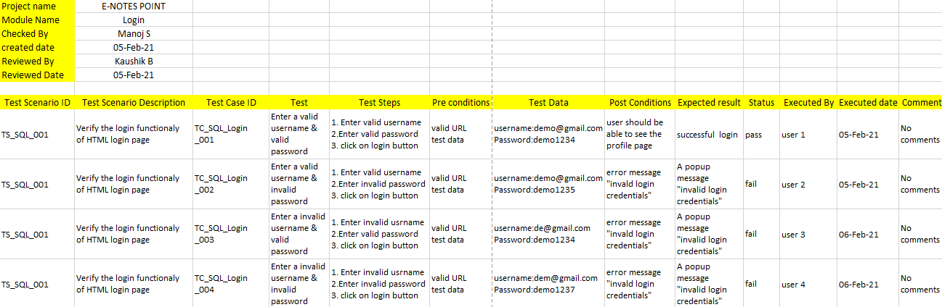

Conclusion

This project is developed with python programming language. The project completely computerises the existing system. Now notes sharing is rather considerably easier that ever by this project.

We would also like that it was very overwhelming to work with python and Django.

This system has been advantageous in all aspects,

* This is a quick WEB BASED application.
* It can be used with minimal training.
* It is helpful for college seniors to help juniors through sharing notes.

Bibliography

Reference:

Software Engineering: Author – Mrs. Vidya. A

Website References:

* <https://www.w3schools.com/>
* <https://www.javatpoint.com/>
* <http://www.telusko.com/>
* <https://www.geeksforgeeks.org/>
* <https://www.python.org/>
* <https://www.tutorialspoint.com/index.htm>
* <https://www.udemy.com/>
* <https://www.youtube.com/>